Summer 1, week 5, yr 7,8,&9 Task sheet

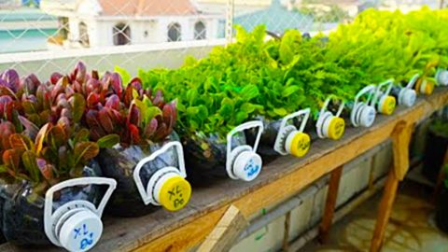 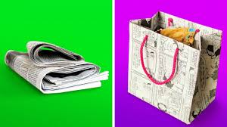

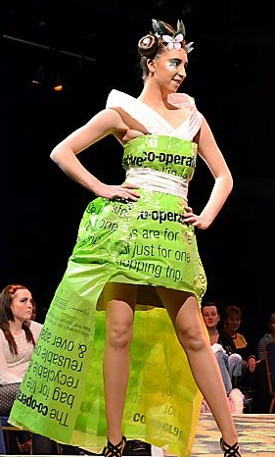 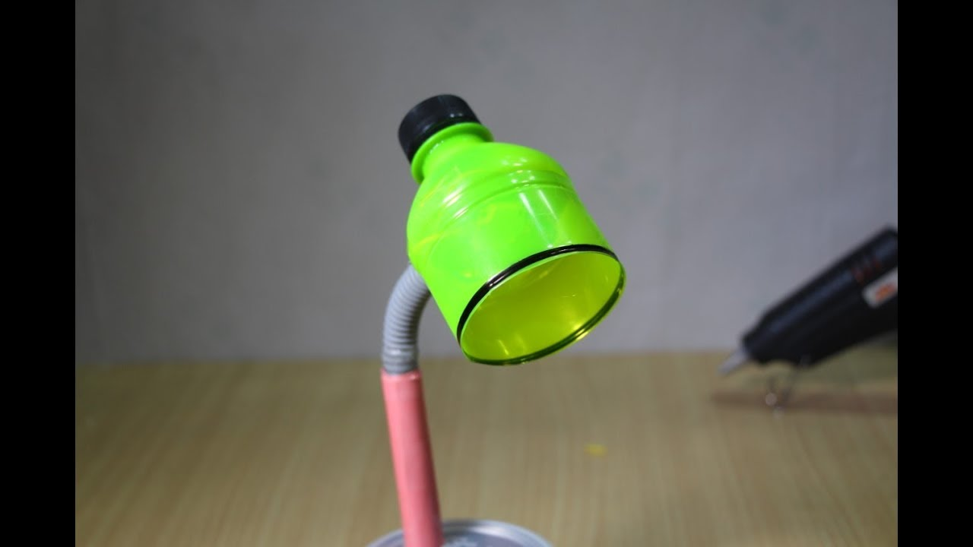

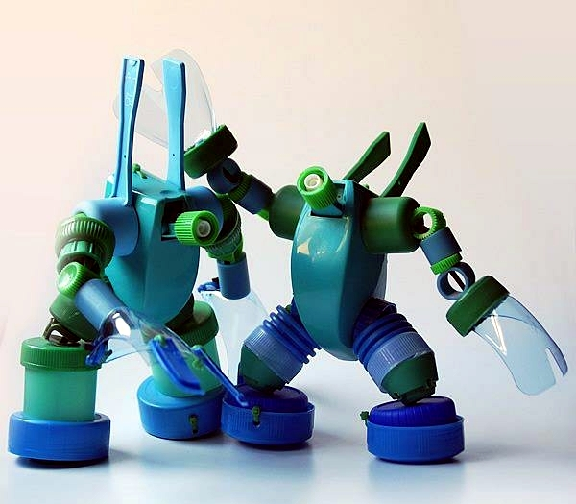

**Task**

**Create something out of recycled materials.**

Collect materials such as:

Boxes, plastics – bottles, tubs bags, bottle tops, newspaper, bags, fabric, cartons etc.

You can choose to make anything from a model to something more useful like a bird feeder or bag, or even an item of clothing.

If you are stuck for ideas check out the internet.