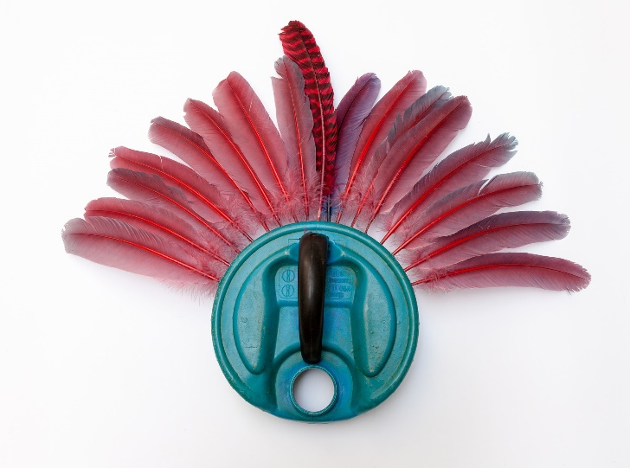 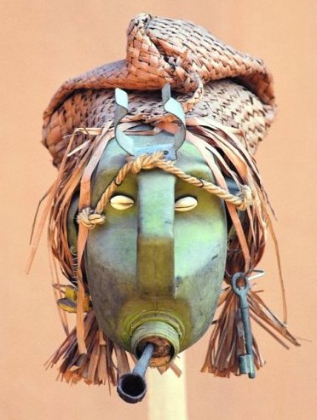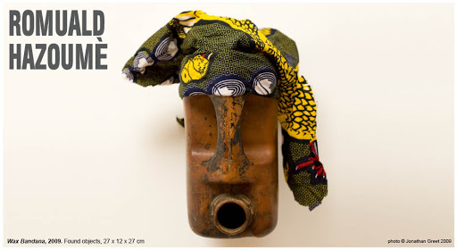

**Summer 1, week 5, Task Sheet yr 9,10 & 11**

**Romuald Hazoumè** was born in 1962 in Porto Novo, in the Republic of Benin. His masks are made with recycled materials, they resonate a long history of African mask making but are also telling of more up-to-date issues.

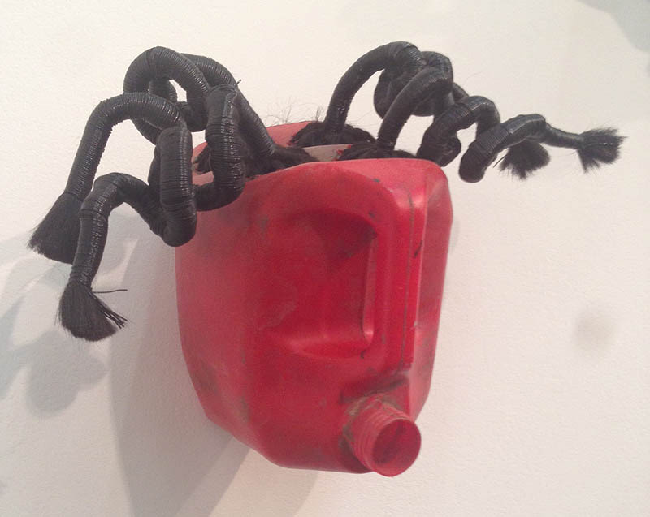

**Task 1**

**Create your own A4 research page on Romuald Hazoume.**

**Include pictures and information on one or more of the issues Romuald encompasses in his work.**

**Task 2**

**Creat your own mask using materials that would otherwise be thrown away.**

**Try to create a mood or personality for your mask.**

**Aim to photograph your work from several angles.**

**Tittle your work**