**Task sheet Summer 2, Week 3 Art, yrs 9 & 10**

**Drawing from Observation**

This week I’m asking you to refer to the work on tone completed some weeks ago and use this in your drawing.

I would like you to have a go at drawing a shoe. (See example)

Use a 2b pencil if you have one, if not an ordinary HB will be fine.

Start with the outline and details then add as much tone as you can to make your drawing come to life.

Before you start put your shoe at a slight diagonal angle in front of you, this is best done at a table, make sure you are comfortable, draw without moving yourself; this doesn’t mean you can’t move your arms or legs, but do not move yourself from the position you started drawing or you will find your shoe looks different.

Refer to your tonal ladders completed earlier. Aim to get a good range of tones from light to dark. You could also try using different marks also practiced recently.

If you are having trouble seeing the different tones, try squinting at your shoe to help you see them better.

Good luck, remember no one else will see your work except me.

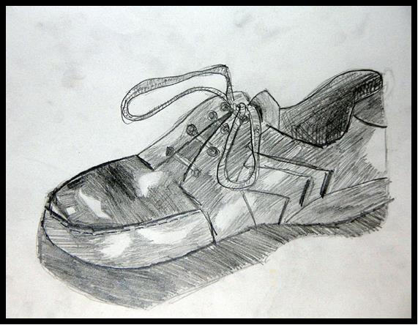Example - Tonal drawing from observation

Top tips:

* Remember when using an eraser to draw the line where you want it, before rubbing out the line in the wrong place.
* Use the side of the lead/pencil to shade rather than rubbing your paper. I promise it will look better.
* Use an eraser to help create the very light areas.