**Task sheet Yr 7, 8 and 9, week 6 summer 1.**

Below are two clips on collage and drawing from the national gallery. Follow one of the tutorials and create your own collage or drawings using the clips to help you.

<https://www.nationalgallery.org.uk/paintings/henri-rousseau-surprised#VideoPlayer95674>

<https://www.youtube.com/watch?v=O8FPIQHfAAw&feature=emb_rel_end> Choose this clip if you are short of materials like coloured pencils/crayons/glue. This only requires a pencil or pen and paper (old envelopes will do)

Take photos of your work and upload to classdojo or email me your finished pieces. l.thomas@marland.devon.sch.uk

If you are unable to watch the clips:

Create a collage inspired by (or your own style copy of) this Henri Rousseau Painting “Surprise”.

**Task 2**

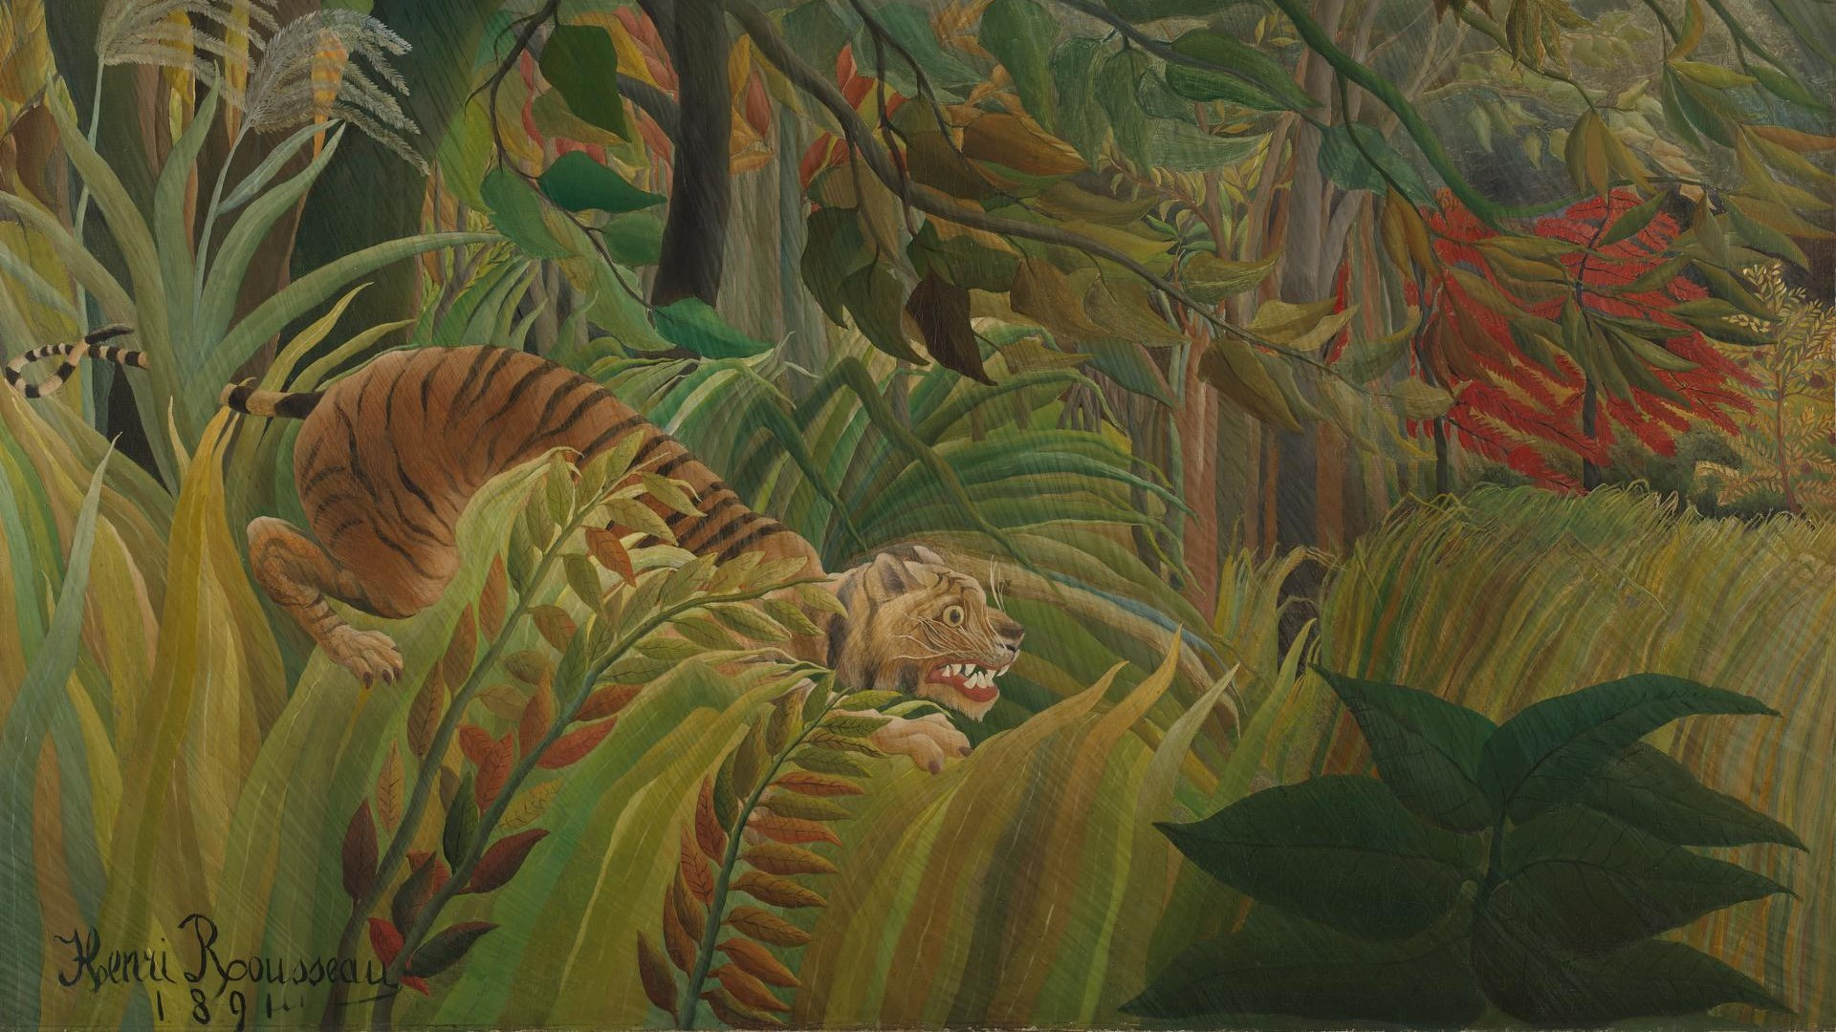What interesting facts can you find out about this painting or this Artist?