**Task sheet Summer 1, Week 6 Art, yrs 9,10 & 11**

**Collage**

Using the images provided (on the additional sheets) cut or tear up the images to produce a completely new A4 image.

You can arrange your pieces in any way you like, as many times as you like.

When you are ready you can glue your pieces or you can continue to change your image. Take photos of the different ways you create your new image/s.

And/or

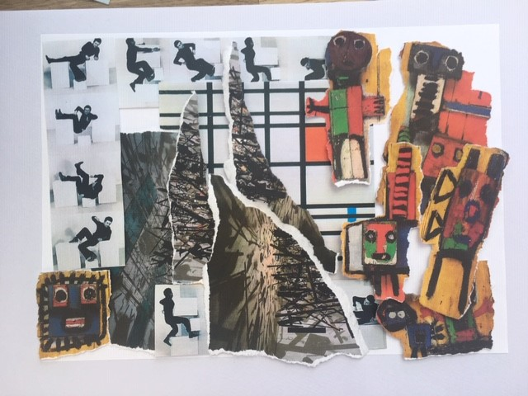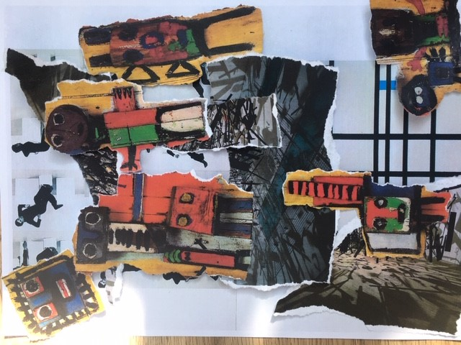Take a photo of your work when you have glued and finished.

Two of my recreations

**Task 2** Research - which image belongs to which artist?

Artists’ names: Cornelia Parker

Karel Appel

Bruce McLean

Peit Mondrian