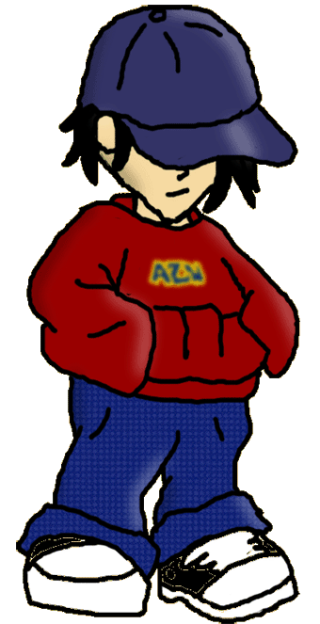

BOREDOM

IMMATURITY

NEED FOR EXCITEMENT

POVERTY

PEER PRESSURE

LACK OF EMPATHY

DRUG/ALCOHOL HABIT