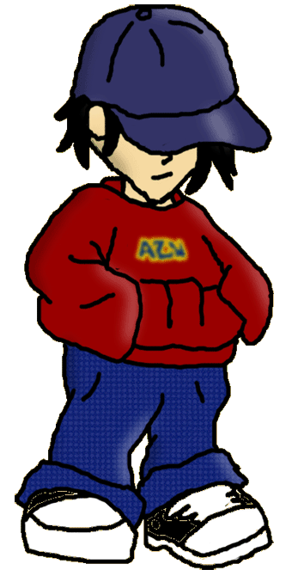

BOREDOM
IMMATURITY
NEED FOR EXCITEMENT
POVERTY
PEER PRESSURE
LACK OF EMPATHY
DRUG/ALCOHOL HABIT

