There was music from my neighbor’s house through the summer nights. In his blue gardens men and girls came and went like moths among the whisperings and the champagne and the stars. At high tide in the afternoon I watched his guests diving from the tower of his raft, or taking the sun on the hot sand of his beach while his two motor-boats slit the waters of the Sound, drawing aquaplanes over cataracts of foam. On week-ends his Rolls-Royce became an omnibus, bearing parties to and from the city between nine in the morning and long past midnight, while his station wagon scampered like a brisk yellow bug to meet all trains. And on Mondays eight servants, including an extra gardener, toiled all day with mops and scrubbing-brushes and hammers and garden-shears, repairing the ravages of the night before.

**In this extract from F. Scott Fitzgerald’s 1925 classic, the narrator, Nick, describes the parties that his neighbour, Jay Gatsby, hosts each weekend.**

Every Friday five crates of oranges and lemons arrived from a fruiterer in New York — every Monday these same oranges and lemons left his back door in a pyramid of pulpless halves. There was a machine in the kitchen which could extract the juice of two hundred oranges in half an hour if a little button was pressed two hundred times by a butler’s thumb.

At least once a fortnight a corps of caterers came down with several hundred feet of canvas and enough colored lights to make a Christmas tree of Gatsby’s enormous garden. On buffet tables, garnished with glistening hors-d’oeuvre, spiced baked hams crowded against salads of harlequin designs and pastry pigs and turkeys bewitched to a dark gold. In the main hall a bar with a real brass rail was set up, and stocked with gins and liquors and with cordials so long forgotten that most of his female guests were too young to know one from another.

By seven o’clock the orchestra has arrived, no thin five-piece affair, but a whole pitful of oboes and trombones and saxophones and viols and cornets and piccolos, and low and high drums. The last swimmers have come in from the beach now and are dressing up-stairs; the cars from New York are parked five deep in the drive, and already the halls and salons and verandas are gaudy with primary colors, and hair shorn in strange new ways, and shawls beyond the dreams of Castile. The bar is in full swing, and floating rounds of cocktails permeate the garden outside, until the air is alive with chatter and laughter, and casual innuendo and introductions forgotten on the spot, and enthusiastic meetings between women who never knew each other’s names.

The lights grow brighter as the earth lurches away from the sun, and now the orchestra is playing yellow cocktail music, and the opera of voices pitches a key higher. Laughter is easier minute by minute, spilled with prodigality[1], tipped out at a cheerful word. The groups change more swiftly, swell with new arrivals, dissolve and form in the same breath; already there are wanderers, confident girls who weave here and there among the stouter and more stable, become for a sharp, joyous moment the centre of a group, and then, excited with triumph, glide on through the sea-change of faces and voices and color under the constantly changing light.

Suddenly one of the gypsies, in trembling opal, seizes a cocktail out of the air, dumps it down for courage and, moving her hands like Frisco, dances out alone on the canvas platform. A momentary hush; the orchestra leader varies his rhythm obligingly for her, and there is a burst of chatter as the erroneous news goes around that she is Gilda Gray’s understudy from the Follies. The party has begun.

**Section A: Reading.**Answer all questions in this section.   
You are advised to spend about 45 minutes on this section.

**Q1:** Read the **first paragraph** again.

List **four** things that the neighbour’s guests do.

**[4 marks]**

**Q2:** Read **paragraphs 1, 4, 5 and 6** again. How does the writer use **language** to describe the guests?  
You could include:

* The writer’s choice of words and phrases
* Language features and techniques
* Sentence forms

**[8 marks]**

**Q3:** You need to think about the **whole extract** now. How has the writer **structured** the text to interest you as a reader?   
You could write about:

* What the writer focuses your attention on at the beginning
* How and why the writer changes this focus as the extract develops
* Any other structural features that interest you

**[8 marks]**

**Q4:** Focus this part of your answer on **the whole of the extract**. A student said: “*F. Scott Fitzgerald successfully brings the party to life for the reader. It is as if you are there in the party.”*To what extent do you agree? In your response, you should:

* Write about your own impressions of the party
* Evaluate how the writer brings it to life
* Support your opinions with quotations from the text

**[20 marks]**

**Section B: Writing**You are advised to spend about **45 minutes** on this section.   
**Write in full sentences**.  
You are reminded of the need to plan your answer.  
You should leave enough time to check your work at the end.

**Q5:** You are going to enter a creative writing competition. Your entry will be judged by a panel of young people of your own age.

**Either:**

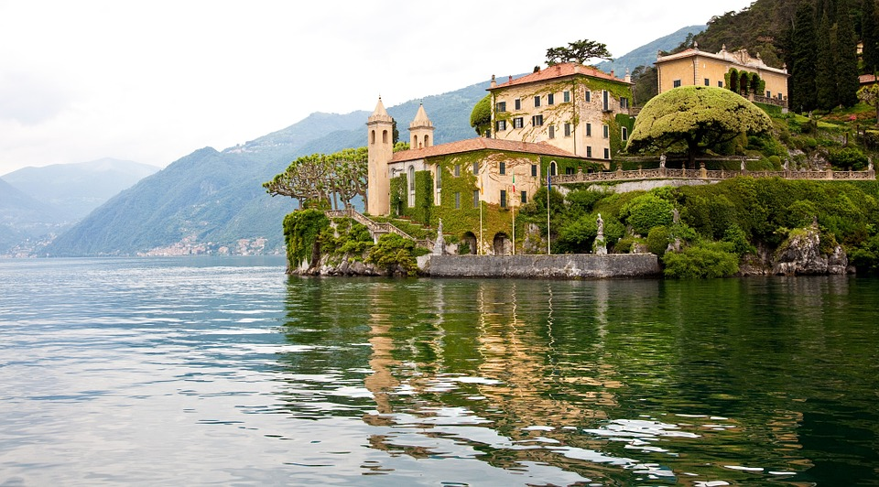Write a **description** suggested by this picture:

**Or:**

Write the **opening** to a **narrative** about a social situation.

**(24 marks for content and organisation,  
16 marks for technical accuracy)  
[40 marks]**

1. **Prodigality** – Excessive spending.