BKSB Student Login
For Groups: A, B, C, and D
These instructions have also been emailed to your school email addresses so you can access the links’
- In your URL Bar: Type https://marland-school.bksblive2.co.uk/
- Enter your login username (the same as your school one) and then your BKSB password, default is your initials you first initial is an uppercase letter followed by 123456 unless you have changed it. (if you have forgotten it send me an email to m.sayer@marland.devon.sch.uk. And I will reset it to the default).
- Once you are logged in you will be presented with the screen below click here.

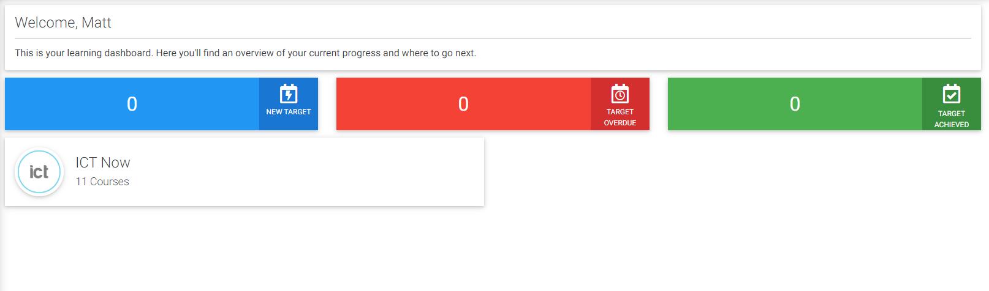
- Next click here

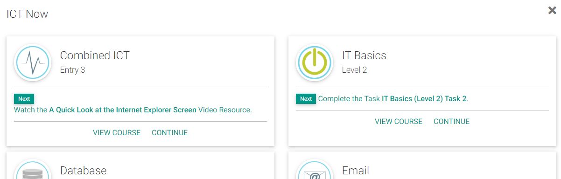

- When you get to the next screen you will see a screen similar to the one below:
- Use the workbook to help you find the answers and then answer them in the student file.
- When you have finished save the file and the select it to upload it here
- Click here to upload it, once it has uploaded click on Home and select the next task as you did above.
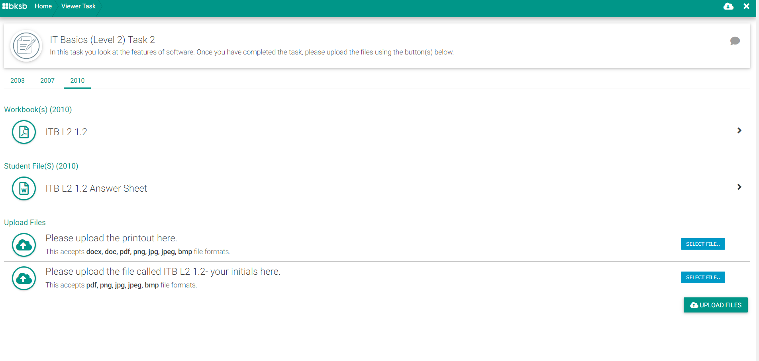
IMPORTANT! If you don’t have access to Microsoft Office at home remember you can use the on-line version via your school Office 365 account (same place as you access your emails and the same login details as your Minecraft educational edition account)
I.e. a.nother@marland.devon.sch.uk and login with your normal school password

