Introduction

A **style** is a predefined combination of font style, colour, and size that can be applied to any text in your document. Styles can help your documents achieve a more professional look and feel. You can also use styles to quickly change several things in your document at the same time.

Watch the video below to learn more about using styles in Word: <https://youtu.be/w2lES-5Ynbk>

To apply a style:

1. Select the text you want to format, or place your cursor at the beginning of the line.



1. In the **Styles** group on the **Home** tab, click the **More** drop-down arrow.

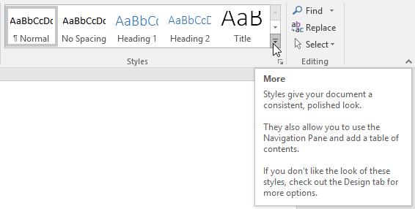

1. Select the **desired style** from the drop-down menu.

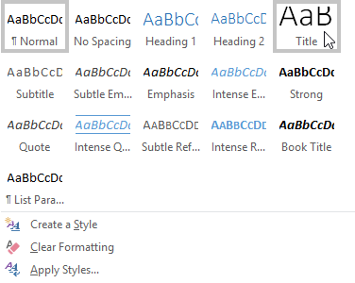

1. The text will appear in the selected style.



To apply a style set:

**Style sets** include a combination of title, heading, and paragraph styles. Style sets allow you to **format all elements** in your document at once instead of modifying each element separately.

1. From the **Design**tab, click the **More** drop-down arrow in the **Document Formatting**group.

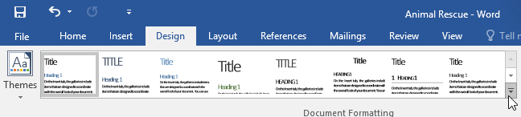

1. Choose the **desired style set**from the drop-down menu.

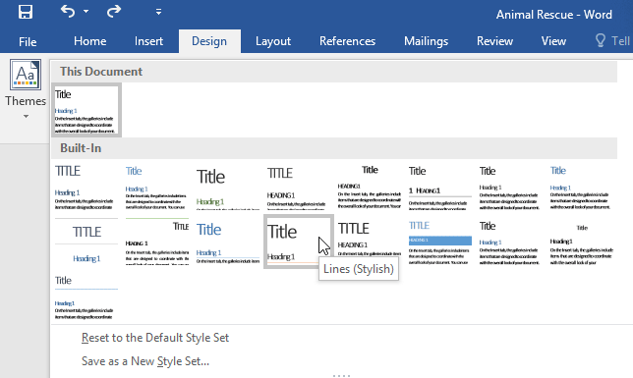

1. The selected style set will be applied to your entire document.



To modify a style:

1. In the **Styles** group on the **Home** tab, right-click the **style** you want to change and select **Modify** from the drop-down menu.

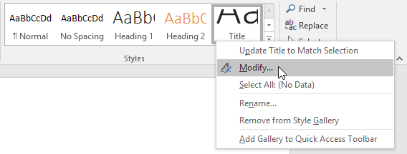

1. A dialog box will appear. Make the **desired formatting** **changes**, such as font style, size, and color. If you want, you can also change the **name** of the style. Click **OK**to save your changes.

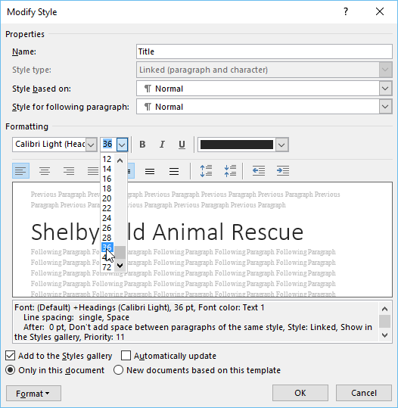

1. The style will be modified.



When you modify a style, you're changing**every instance** of that style in the document. In the example below, we've modified the **Normal** style to use a larger font size. Because both paragraphs use the Normal style, they've been updated automatically to use the new size.

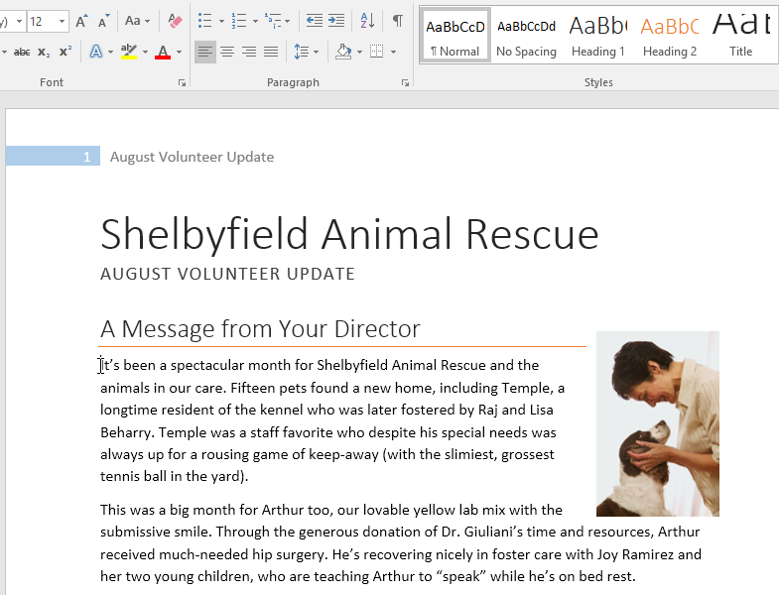

To create a new style:

1. Click the **arrow** in the bottom-right corner of the **Styles** group.

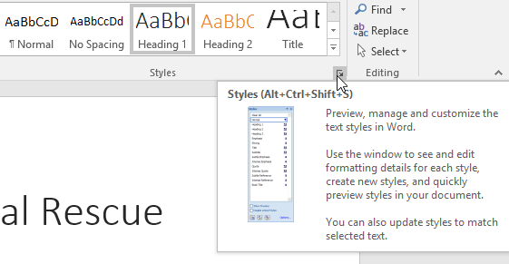

1. The **Styles** task pane will appear. Select the **New Style** button at the bottom of the task pane.

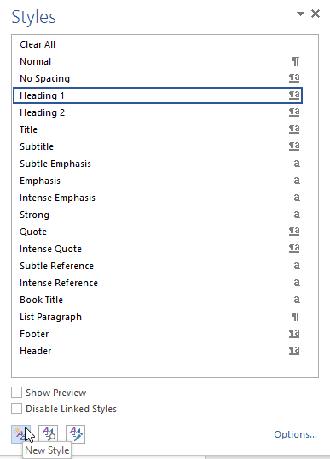

1. A dialog box will appear. Enter a **name** for the style, choose the **desired text formatting**, then click **OK**.

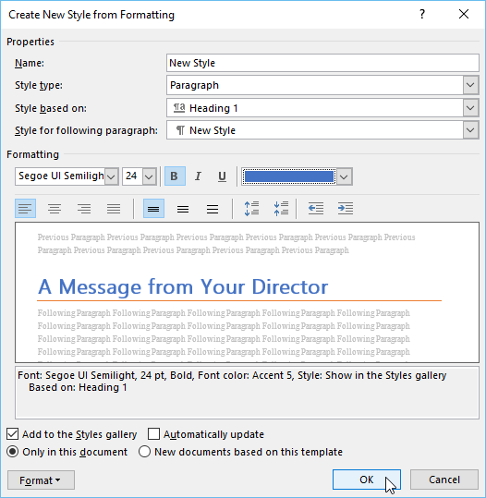

1. The new style will be applied to the currently selected text. It will also appear in the **Styles** group.

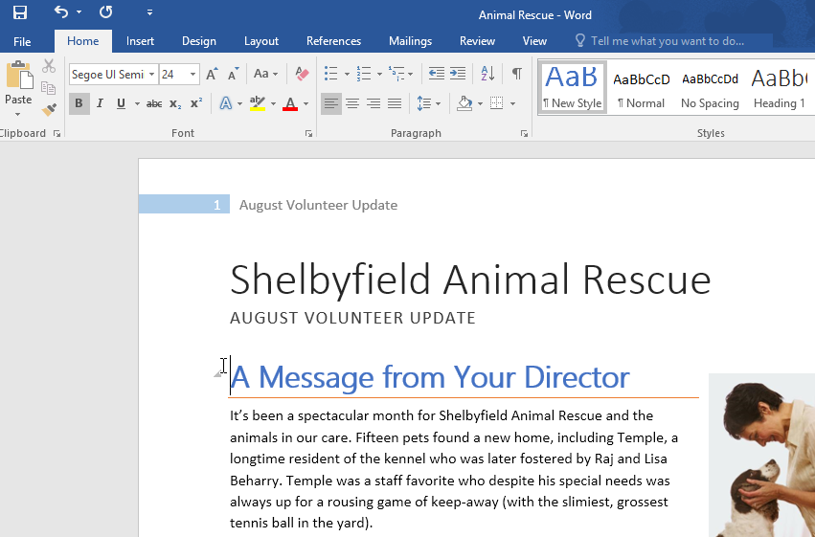

You can also use styles to create a **table of contents** for your document. To learn how, review our article on [**How to Create a Table of Contents in Microsoft Word**](http://www.gcflearnfree.org/word-tips/how-to-create-a-table-of-contents-in-word/1/).

Challenge!

1. Open our [**practice document**](https://media.gcflearnfree.org/content/5c0969a177c0500354728589_12_06_2018/word_styles_practice.docx). If you already downloaded our practice document, be sure to download a fresh copy by clicking the link again.
2. On page 1, select the first line of text **Shelbyfield Animal Rescue** and change the style to **Title**.
3. Select the second line that says **August Volunteer Update**and change the style to **Heading 1**.
4. Select the third line that says **A Message From Your Director** and change the style to **Heading 2**.
5. In the **Design** tab, change the **style set** to **Casual**.
6. **Modify** the **Normal** style so the font is**Cambria** and the font size is **14 pt**.
7. When you're finished, the first page of your document should look like this:



1. Optional: Modify the **Heading 3** style any way you want. You can change the font, font size, colour, and more. This heading appears throughout the document, so try to choose formatting that complements the body text.