Introduction

The **header** is a section of the document that appears in the **top margin**, while the **footer** is a section of the document that appears in the **bottom margin**. Headers and footers generally contain additional information such as **page numbers**, **dates**, **an** **author's name**, and **footnotes**, which can help keep longer documents organized and make them easier to read. Text entered in the header or footer will appear on **each page** of the document.

Optional: Download our [**practice document**](https://media.gcflearnfree.org/content/5c094f1977c050035472856e_12_06_2018/word_headersfooters_practice.docx).

Watch the video below to learn more about headers and footers in Word.

<https://youtu.be/lNdjuIYuB3o>

To create a header or footer:

In our example, we want to display the author's name at the top of each page, so we'll place it in the header.

1. Double-click anywhere on the **top or bottom margin** of your document. In our example, we'll double-click the top margin.

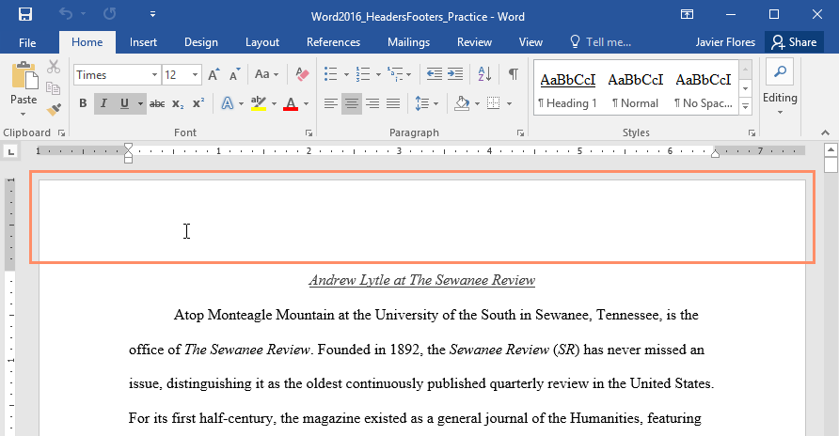

1. The header or footer will open, and a **Design** tab will appear on the right side of the**Ribbon**. The insertion point will appear in the header or footer.

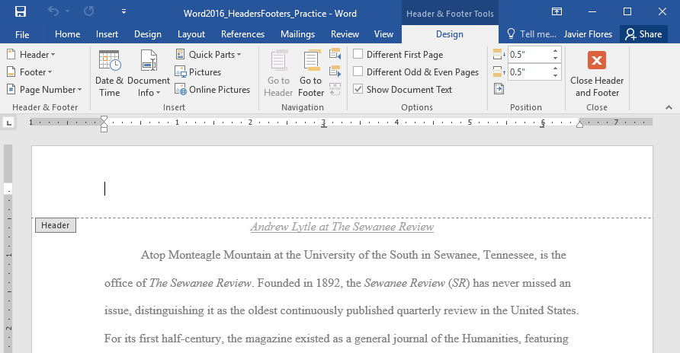

1. Type the**desired information** into the header or footer. In our example, we'll type the author's name and the date.

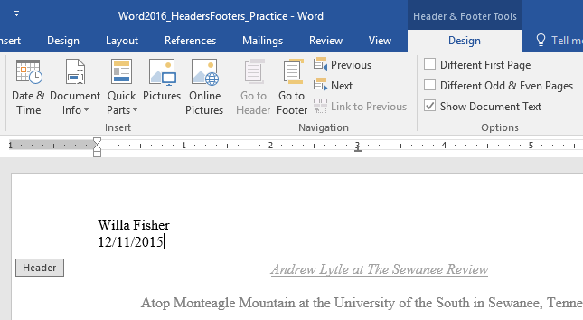

1. When you're finished, click **Close Header and Footer**. You can also press the **Esc** key.

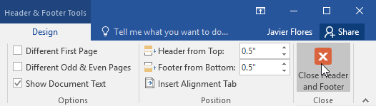

1. The header or footer text will appear.

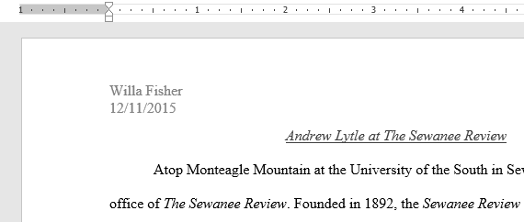

To insert a preset header or footer:

Word has a variety of **preset headers and footers** you can use to enhance your document's design and layout. In our example, we'll add a preset header to our document.

1. Select the **Insert** tab, then click the **Header** or **Footer** command. In our example, we'll click the **Header** command.

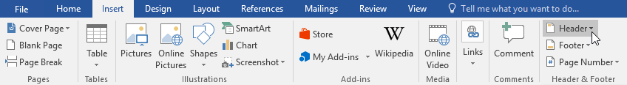

1. In the menu that appears, select the desired **preset header or footer**.

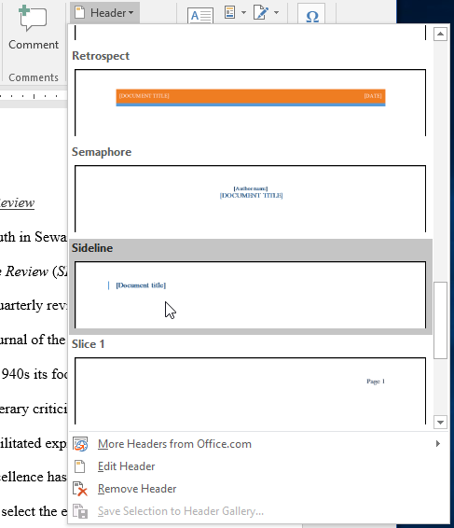

1. The header or footer will appear. Many preset headers and footers contain text placeholders called **Content Control** fields. These fields are good for adding information like the document title, author's name, date, and page number.

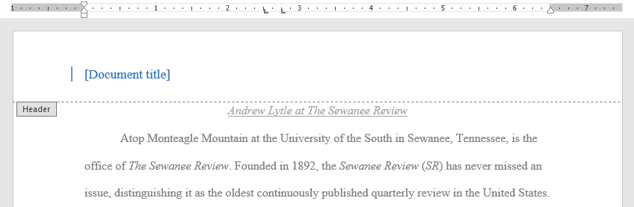

1. To edit a Content Control field, click it and type the **desired information**.

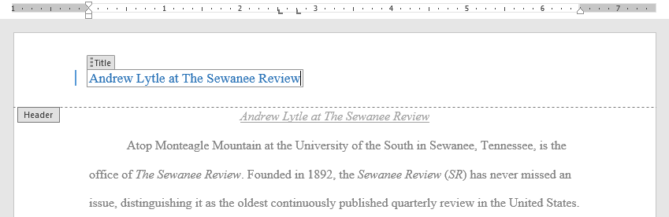

1. When you're finished, click **Close Header and Footer**. You can also press the **Esc** key.



If you want to delete a Content Control field, right-click it and select **Remove Content Control** from the menu that appears.

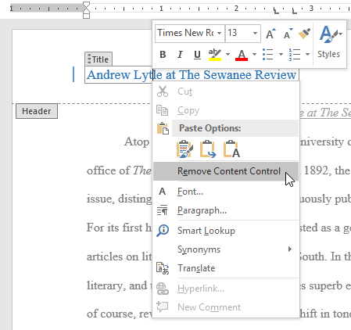

Editing headers and footers

After you close the header or footer, it will still be visible, but it will be **locked**. Simply double-click a header or footer to **unlock** it, which will allow you to edit it.

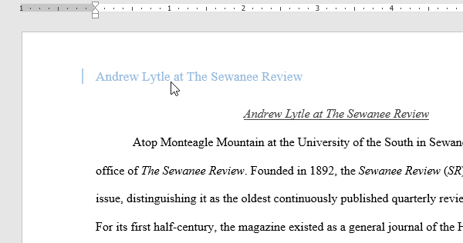

Design tab options

When your document's header and footer are unlocked, the **Design** tab will appear on the right side of the Ribbon, giving you various editing options:

* **Hide the first-page header and footer**: For some documents, you may not want the first page to show the header and footer, like if you have a cover page and want to start the page numbering on the second page. If you want to hide the first-page header and footer, check the box next to **Different First Page**.

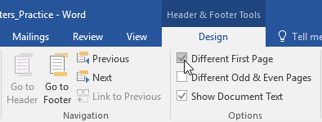

* **Remove the header or footer**: If you want to remove all information contained in the header, click the **Header** command and select **Remove Header** from the menu that appears. Similarly, you can remove a footer using the **Footer** command.

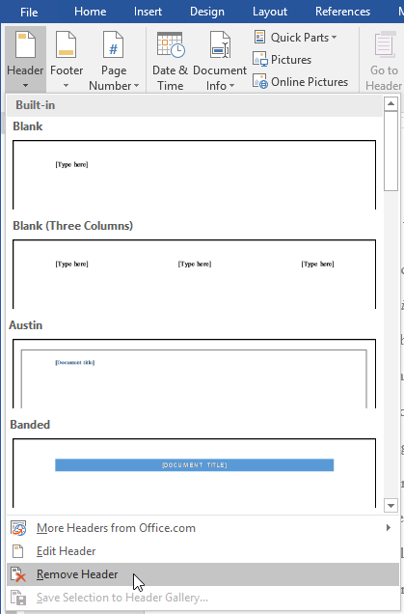

* **Page Number**: You can automatically number each page with the Page Number command. Review our [**Page Numbers**](https://edu.gcfglobal.org/en/word/page-numbers/1/) lesson to learn more.

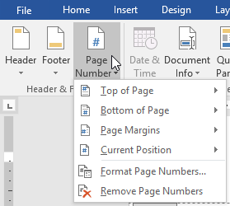

* **Additional options**: With the commands available in the Insert group, you can add the **date and time**, **document info**, **pictures**, and more to your header or footer.

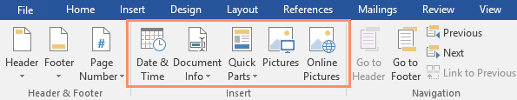

To insert the date or time into a header or footer:

Sometimes it's helpful to include the **date or time** in the header or footer. For example, you may want your document to show the **date when it was created**.

On the other hand, you may want to show the **date when it was printed**, which you can do by setting it to **update automatically**. This is useful if you frequently update and print a document because you'll always be able to tell which version is the most recent.

1. Double-click anywhere on the header or footer to **unlock** it. Place the **insertion point** where you want the date or time to appear. In our example, we'll place the insertion point on the line below the author's name.

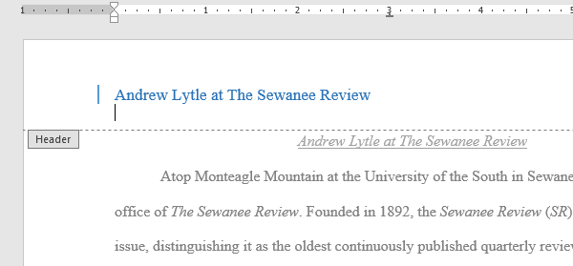

1. The **Design** tab will appear. Click the **Date & Time** command.

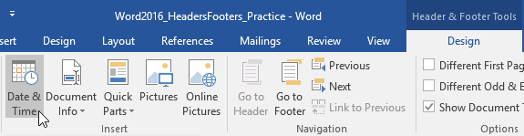

1. The **Date and Time** dialog box will appear. Select the desired **date**or **time format**.
2. Check the box next to **Update automatically** if you want the date to change every time you open the document. If you don't want the date to change, leave this option unchecked.
3. Click **OK**.

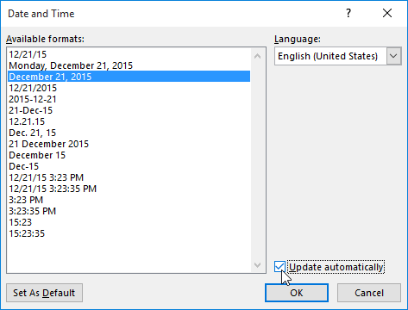

1. The date will appear in the header.

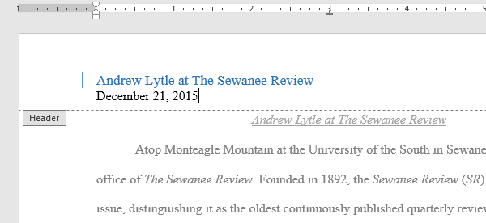

Challenge!

1. Open our [**practice document**](https://media.gcflearnfree.org/content/5c094f1977c050035472856e_12_06_2018/word_headersfooters_practice.docx). If you've already downloaded our practice document to follow along with the lesson, be sure to download a fresh copy by clicking the link in this step.
2. Open the **header**.
3. Choose **Align Right** on the **Home** tab and type your name.
4. Below your name, use the **Date & Time** command on the **Design** tab and insert the date using whatever format you want.
5. In the **footer** section, insert the preset footer **Grid**. If your version of Word doesn't have a Grid preset, you can choose any available preset.
6. **Close** the header and footer.
7. When you're finished, your page should look something like this:

