Introduction

Indenting text adds structure to your document by allowing you to separate information. Whether you'd like to move a single line or an entire paragraph, you can use the **tab selector** and the **horizontal ruler** to set **tabs** and **indents**.

Optional: Download our [**practice document**](https://media.gcflearnfree.org/content/5c09480b77c050035472855d_12_06_2018/word_indentstabs_practice.docx).

Watch the video below to learn more about how to use indents and tabs in Word.

<https://youtu.be/vJGYWVe52T>4

Indenting text

In many types of documents, you may want to indent only the first line of each paragraph. This helps to **visually** **separate** paragraphs from one another.



It's also possible to indent every line **except for the first line**, which is known as a **hanging indent**.

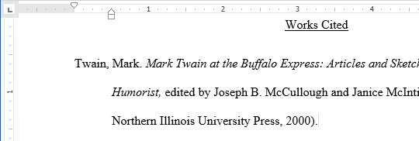

To indent using the Tab key:

A quick way to indent is to use the **Tab** key. This will create a first-line indent of **1/2 inch**.

1. Place the insertion point **at the very beginning** of the paragraph you want to indent.



1. Press the **Tab** key. On the Ruler, you should see the **first-line indent marker** move to the right by **1/2 inch**.
2. The first line of the paragraph will be indented.



If you can't see the Ruler, select the **View** tab, then click the checkbox next to the **Ruler**.

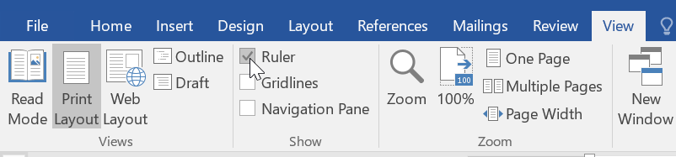

Indent markers

In some cases, you may want to have more control over indents. Word provides **indent markers** that allow you to indent paragraphs to the location you want.

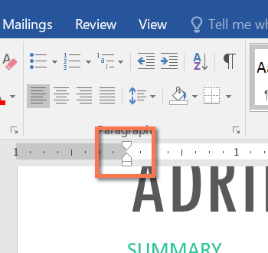

The indent markers are located to the left of the horizontal ruler, and they provide several indenting options:

* **First-line indent marker**first-line indent adjusts the first-line indent
* **Hanging indent marker**hanging indent adjusts the hanging indent
* **Left indent marker**left indent moves **both** the first-line indent and hanging indent markers at the same time (indenting all lines in a paragraph)

To indent using the indent markers:

1. Place the **insertion point** anywhere in the paragraph you want to indent, or select one or more paragraphs.

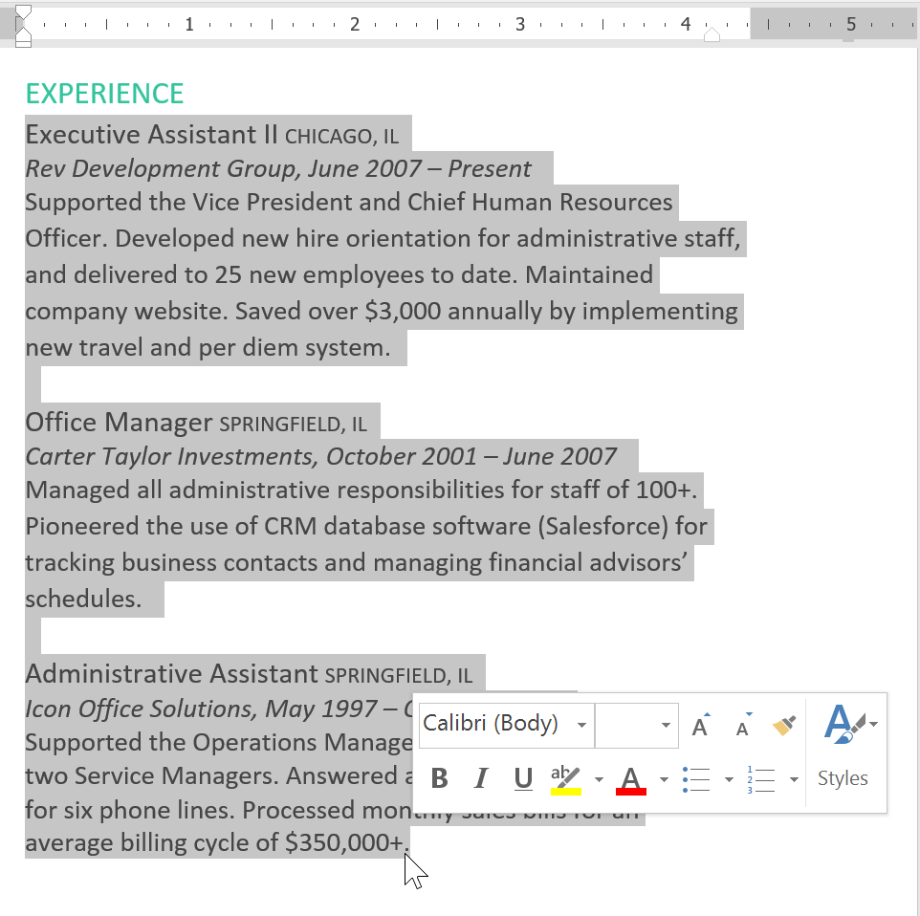

1. Click and drag the desired**indent marker**. In our example, we'll click and drag the left indent marker.

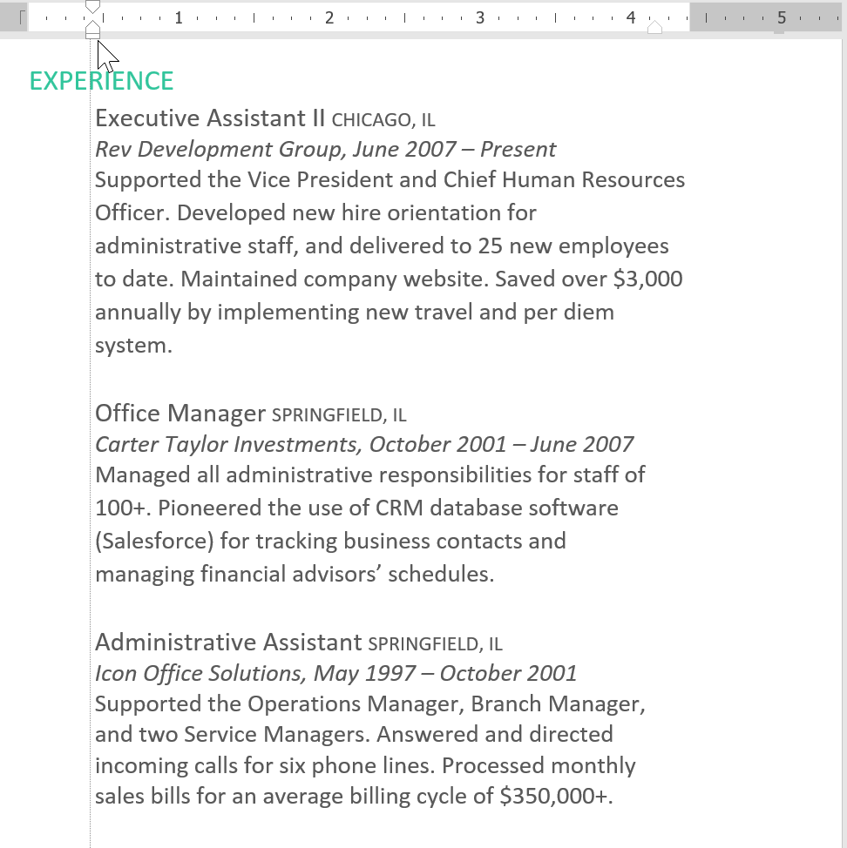

1. Release the mouse. The paragraphs will be indented.

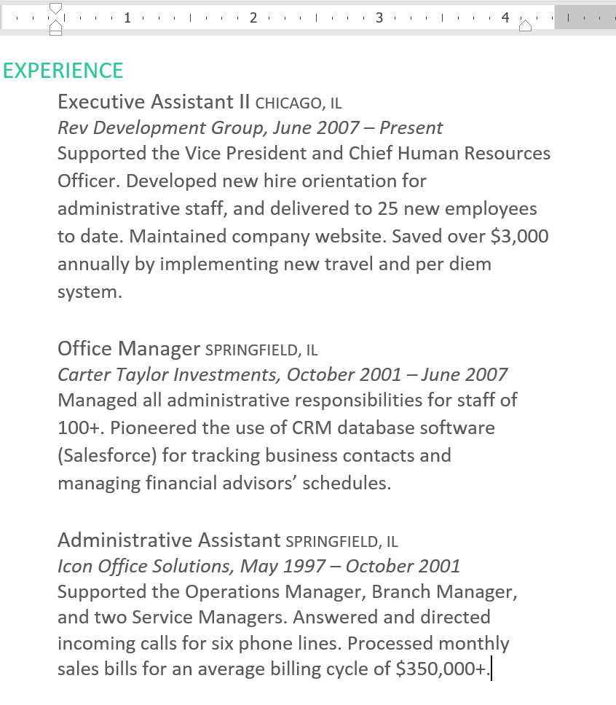

To indent using the Indent commands:

If you want to indent multiple lines of text or all lines of a paragraph, you can use the **Indent commands**. The Indent commands will adjust the indent by **1/2-inch increments**.

1. Select the text you want to indent.

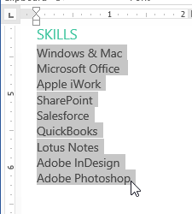

1. On the **Home** tab, click the **Increase Indent**or **Decrease Indent** command.

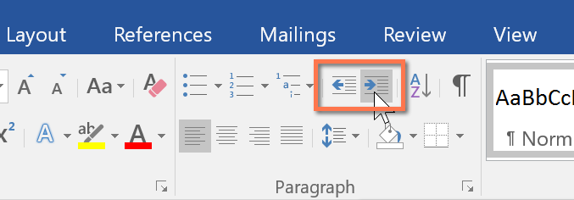

1. The text will indent.

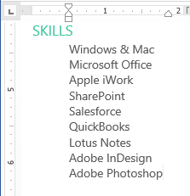

To customize the indent amounts, select the **Layout** tab near the desired values in the boxes under **Indent**.

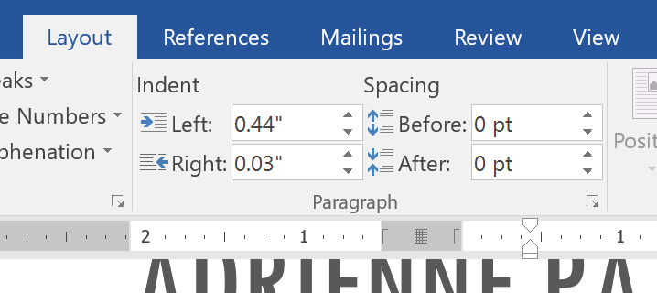

Tabs

Using **tabs** gives you more control over the placement of text. By default, every time you press the Tab key, the insertion point will move **1/2 inch** to the right. Adding **tab stops** to the **Ruler** allows you to change the size of the tabs, and Word even allows you to apply more than one tab stop to a single line. For example, on a resume you could **left-align** the beginning of a line and **right-align** the end of the line by adding a **Right Tab**, as shown in the image below.

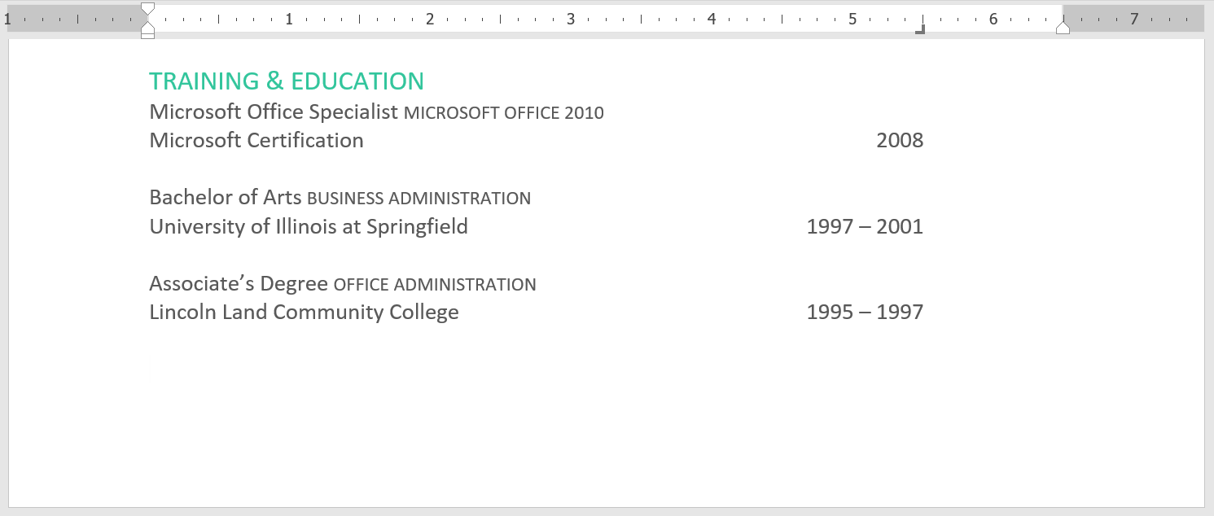

Pressing the Tab key can either add a **tab** or create a **first-line indent**, depending on where the insertion point is. Generally, if the insertion point is at the beginning of an existing paragraph, it will create a first-line indent; otherwise, it will create a tab.

The tab selector

The **tab selector** is located above the **vertical ruler** on the left. Hover the mouse over the tab selector to see the name of the active **tab stop**.

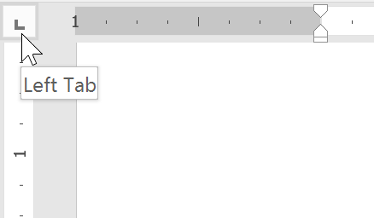

Types of tab stops:

* **Left Tab**left tab stop left-aligns the text at the tab stop
* **Center Tab** center tab stop centers the text around the tab stop
* **Right Tab**right tab stop right-aligns the text at the tab stop
* **Decimal Tab**decimal tab aligns decimal numbers using the decimal point
* **Bar Tab**bar tab draws a vertical line on the document
* **First Line Indent**first line indent inserts the indent marker on the Ruler and indents the first line of text in a paragraph
* **Hanging Indent**hanging indent inserts the hanging indent marker and indents all lines other than the first line

Although **Bar Tab**,**First Line Indent**, and **Hanging Indent** appear on the **tab selector**, they're not technically tabs.

To add tab stops:

1. Select the paragraph or paragraphs you want to add tab stops to. If you don't select any paragraphs, the tab stops will apply to the **current paragraph** and any **new paragraphs** you type below it.

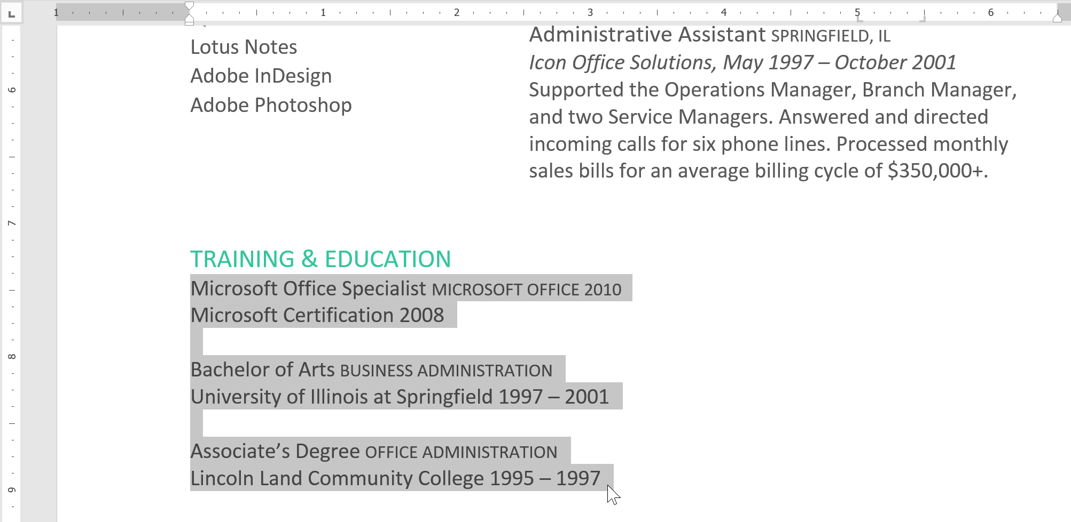

1. Click the **tab selector** until the tab stop you want to use appears. In our example, we'll select **Right Tab**.

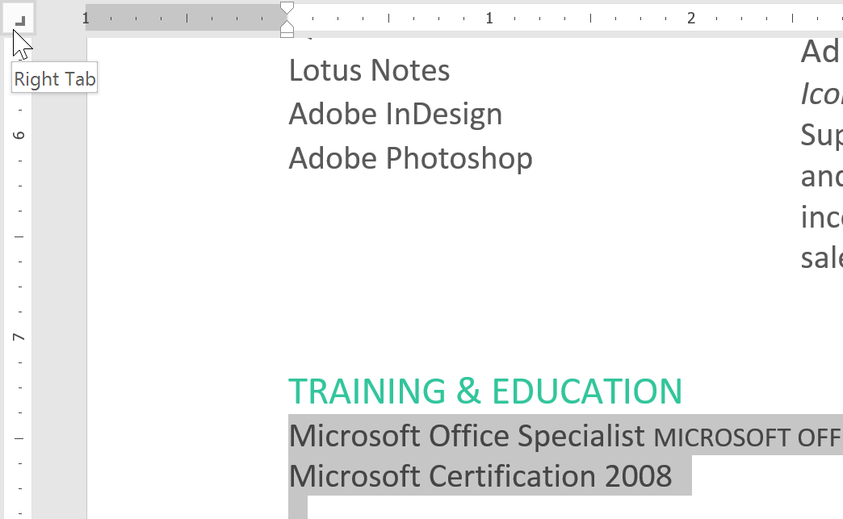

1. Click the **location on the horizontal ruler** where you want your text to appear (it helps to click the **bottom edge** of the Ruler). You can add as many tab stops as you want.

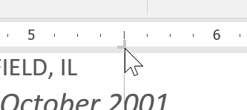

1. Place the **insertion point** in front of the **text** you want to tab, then press the **Tab** key. The text will jump to the next tab stop. In our example, we will move each date range to the tab stop we created.

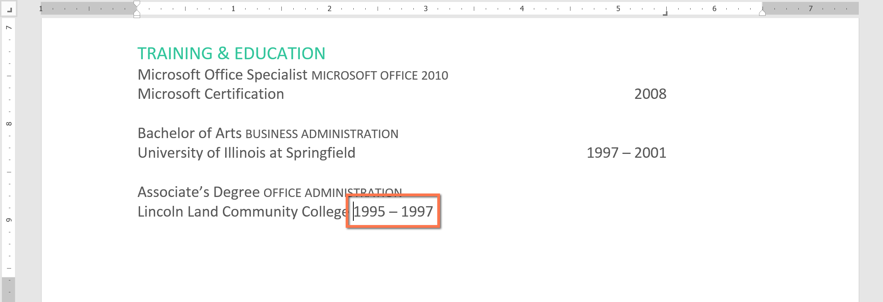

Removing tab stops

It's a good idea to remove any tab stops you aren't using so they don't get in the way. To remove a tab stop, first select all of the text that uses the tab stop. Then click and drag it off of the Ruler.

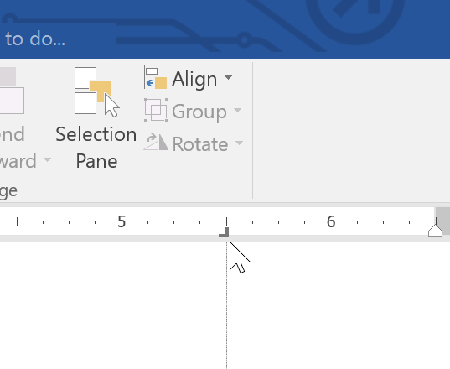

Word can also display hidden formatting symbols such as spaces (space symbol), paragraph marks (paragraph mark), and tabs (tab symbol) to help you see the formatting in your document. To show hidden formatting symbols, select the **Home** tab, then click the **Show/Hide** command.

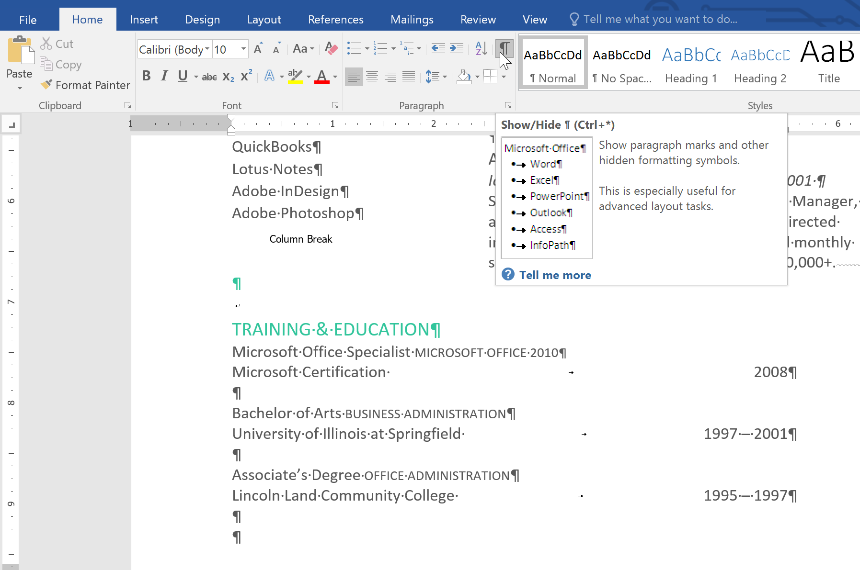

Challenge!

1. Open our [**practice document**](https://media.gcflearnfree.org/content/5c09480b77c050035472855d_12_06_2018/word_indentstabs_practice.docx).
2. Use the **Tab key** to indent the beginning of each paragraph in the body of the cover letter. These start with **I am exceedingly interested**, **While working toward**, and **Enclosed is a copy**.
3. When you're finished, the first page should look like this:



1. Scroll to **page 2**.
2. Select all of the text below **Training & Education** on page 2.
3. Place a **right tab** at the 6" (15.25 cm) mark.
4. Insert your cursor before each date range, then press the **Tab key**. These dates include **2008**, **1997-2001**, and **1995-1997**.
5. Select each job description under the **Experience** section, and move the **left indent** to the 0.25" (50 mm) mark.
6. When you're finished, page 2 should look something like this:

