Introduction

Bulleted and numbered lists can be used in your documents to outline, arrange, and emphasize text. In this lesson, you will learn how to **modify existing bullets**, insert new **bulleted** and **numbered lists**, select **symbols** as bullets, and format **multilevel lists**.

Optional: Download our [**practice document**](https://media.gcflearnfree.org/content/5c09491177c0500354728561_12_06_2018/word_lists_practice.docx).

Watch the video below to learn more about lists in Word.

<https://youtu.be/tyXahko-tX8>

To create a bulleted list:

1. Select the text you want to format as a list.

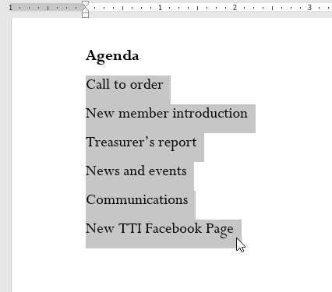

1. On the **Home** tab, click the **drop-down arrow** next to the **Bullets** command. A menu of bullet styles will appear.

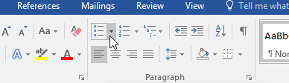

1. Move the mouse over the various bullet styles. A live preview of the bullet style will appear in the document. Select the bullet style you want to use.

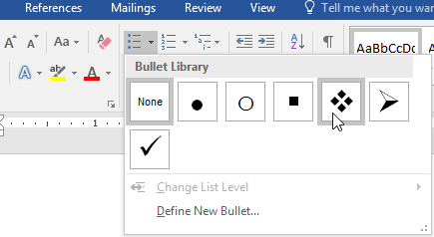

1. The text will be formatted as a bulleted list.

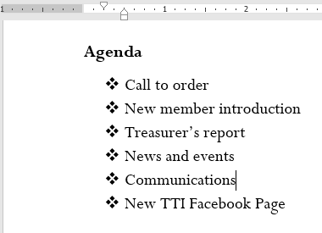

Options for working with lists

* To remove numbers or bullets from a list, select the list and click the **Bulleted** or **Numbered list** command.
* When you're editing a list, you can press **Enter** to start a new line, and the new line will automatically have a bullet or number. When you've reached the end of your list, press **Enter** twice to return to normal formatting.
* By dragging the indent markers on the Ruler, you can customize the indenting of your list and the distance between the text and the bullet or number.

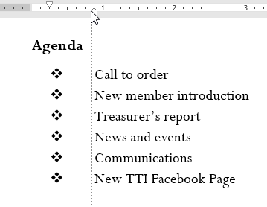

To create a numbered list:

When you need to organize text into a **numbered** list, Word offers several **numbering** options. You can format your list with **numbers**, **letters**, or **Roman numerals**.

1. Select the text you want to format as a list.

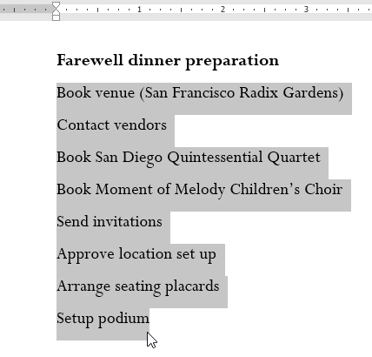

1. On the **Home** tab, click the **drop-down arrow** next to the **Numbering** command. A menu of numbering styles will appear.

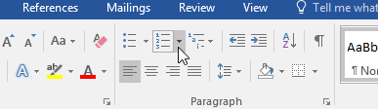

1. Move the mouse over the various numbering styles. A live preview of the numbering style will appear in the document. Select the numbering style you want to use.

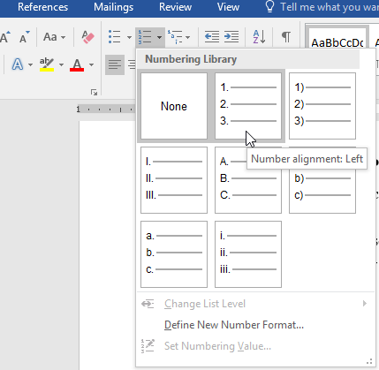

1. The text will format as a numbered list.

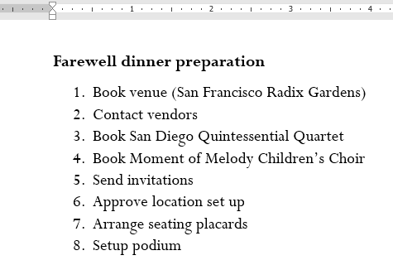

To restart a numbered list:

If you want to restart the numbering of a list, Word has a **Restart at 1**option. It can be applied to **numeric** and **alphabetical** lists.

1. Right-click the**list item** you want to restart the numbering for, then select **Restart at 1** from the menu that appears.

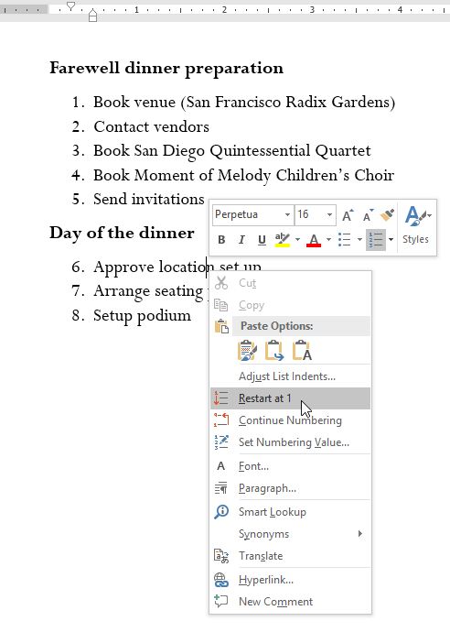

1. The list numbering will restart.

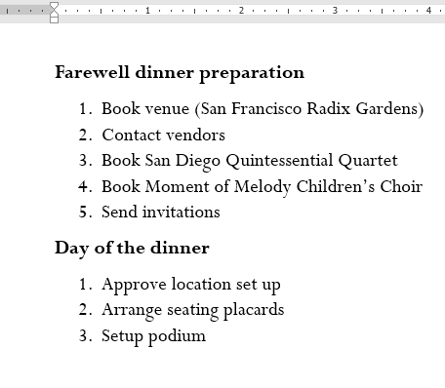

You can also set a list to continue numbering from the previous list. To do this, right-click and select **Continue Numbering**.

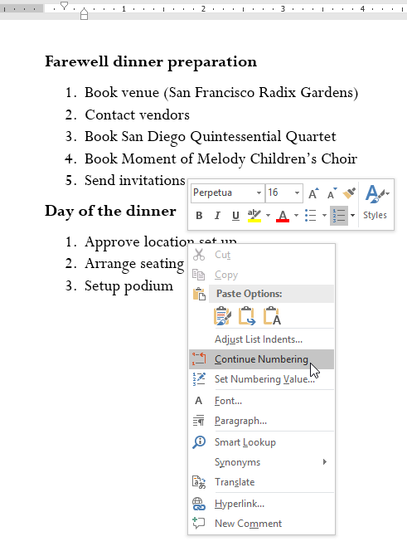

Customizing bullets

Customizing the look of the bullets in your list can help you emphasize certain list items and personalize the design of your list. Word allows you to format bullets in a variety of ways. You can use **symbols**and different **colors**, or even upload a **picture** as a bullet.

To use a symbol as a bullet:

1. Select an existing list you want to format.

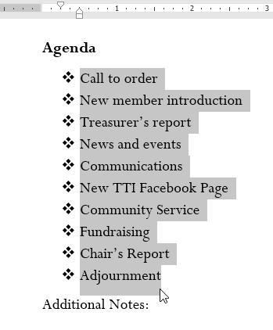

1. On the **Home** tab, click the **drop-down arrow** next to the **Bullets** command. Select **Define New Bullet** from the drop-down menu.

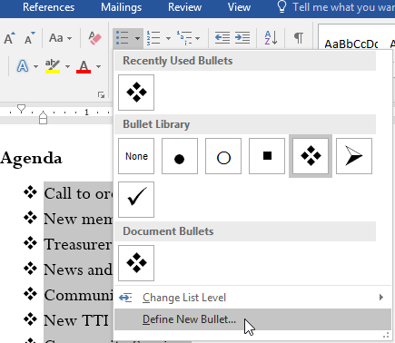

1. The **Define New Bullet** dialog box will appear. Click the **Symbol** button.

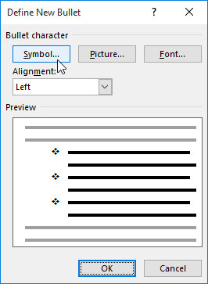

1. The **Symbol** dialog box will appear.
2. Click the **Font** drop-down box and select a font. The **Wingdings** and **Symbol** fonts are good choices because they have many useful symbols.
3. Select the desired symbol, then click **OK**.

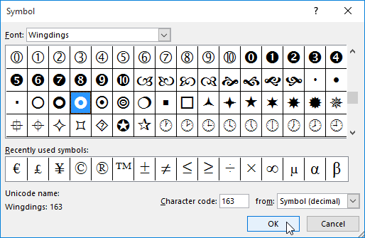

1. The symbol will appear in the Preview section of the Define New Bullet dialog box. Click **OK**.

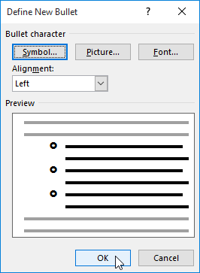

1. The symbol will appear in the list.

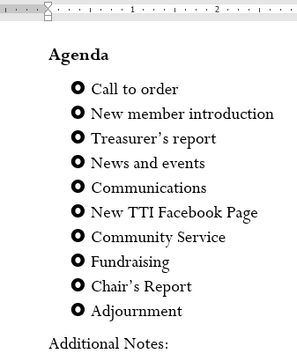

To change the bullet color:

1. Select an existing list you want to format.

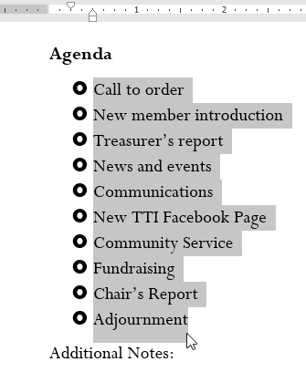

1. On the **Home** tab, click the **drop-down arrow** next to the **Bullets** command. Select **Define New Bullet** from the drop-down menu.

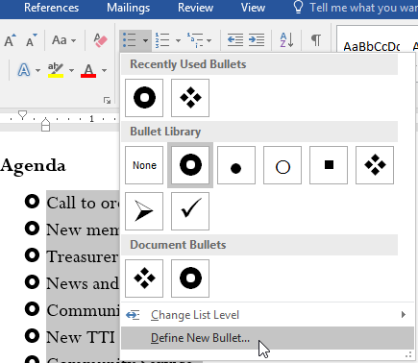

1. The **Define New Bullet** dialog box will appear. Click the **Font** button.

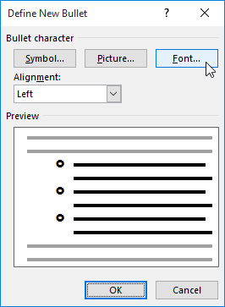

1. The **Font** dialog box will appear. Click the **Font Color** drop-down box. A menu of font colors will appear.
2. Select the desired color, then click **OK**.

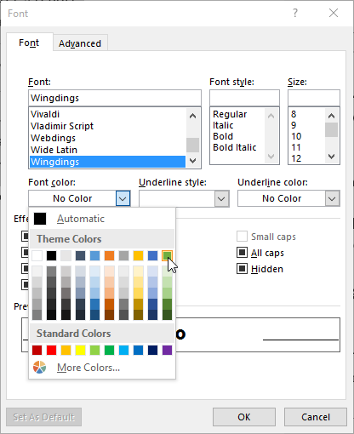

1. The bullet color will appear in the Preview section of the Define New Bullet dialog box. Click **OK**.

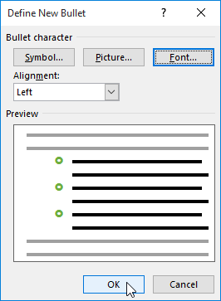

1. The bullet color will change in the list.

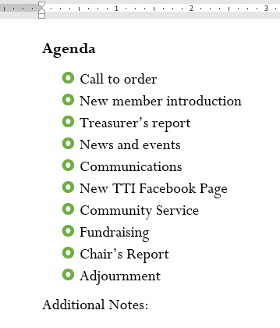

Multilevel lists

Multilevel lists allow you to create an **outline** with **multiple levels**. Any bulleted or numbered list can be turned into a multilevel list by using the **Tab** key.

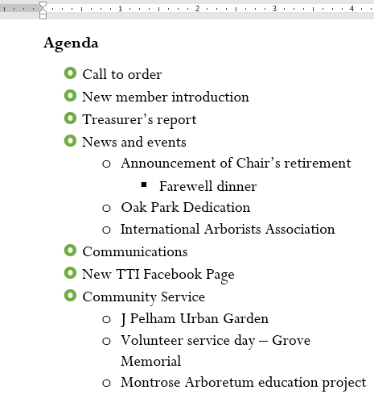

To create a multilevel list:

1. Place the **insertion point** at the beginning of the line you want to move.

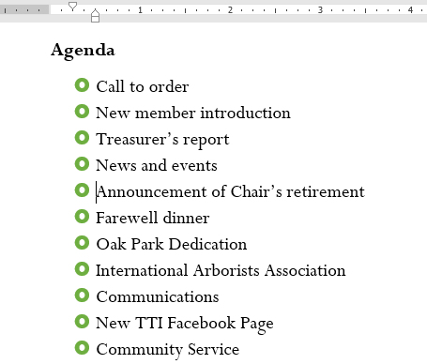

1. Press the **Tab** key to increase the indent level of the line. The line will move to the right.

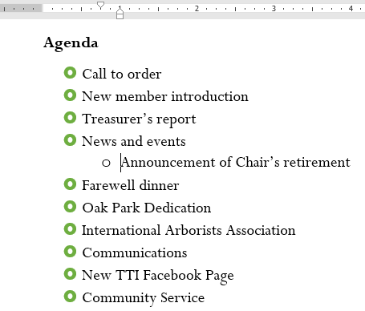

To increase or decrease an indent level:

You can make adjustments to the organization of a multilevel list by increasing or decreasing the indent levels. There are several ways to change the indent level.

* To **increase** the indent by **more than one** level, place the insertion point at the beginning of the line, then press the **Tab** key until the desired level is reached.

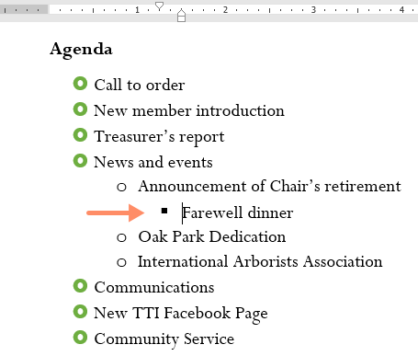

* To **decrease** the indent level, place the insertion point at the beginning of the line, then hold the **Shift** key and press the **Tab** key.

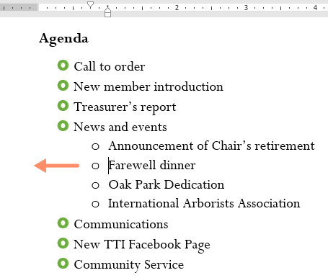

* You can also increase or decrease the levels of text by placing the insertion point anywhere in the line and clicking the **Increase Indent** or **Decrease Indent** commands.

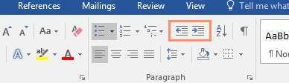

When formatting a multilevel list, Word will use the default bullet style. To change the style of a multilevel list, select the list, then click the **Multilevel list** command on the **Home** tab.

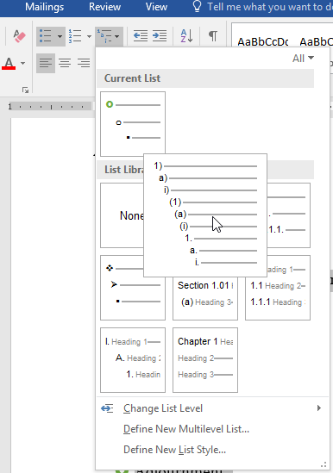

Challenge!

1. Open our [**practice document**](https://media.gcflearnfree.org/content/5c09491177c0500354728561_12_06_2018/word_lists_practice.docx).
2. Scroll to **page 3**.
3. Select the text under **New Members** starting with **Carolyn** and ending with **Co-Treasurer**, and format it as a **bulleted list**.
4. With the text still selected, use the **Define New Bullet** dialog box to change the bullets to a **green star**. **Hint**: You can find a star in the Wingdings font.
5. **Increase** the indent level **by 1** for the lines **Social Media Marketing**, **Fundraising**, and **Co-Treasurer**.
6. **Increase**the indent level **by 2** for the line **Primarily Europe**.
7. In the **Treasurer's Report** list, **decrease** the indent level **by 1** for the line **Amount available this month**.
8. In the **Communications Report** list, **restart the numbering** at 1.
9. When you're finished, your page should look something like this:

