Introduction

Word offers a variety of page layout and formatting options that affect how content appears on the page. You can customize the **page orientation**,**paper size**, and **page margins**depending on how you want your document to appear.

Optional: Download our [**practice document**](https://media.gcflearnfree.org/content/5c09497777c0500354728565_12_06_2018/word_pagelayout_practice.docx).

Watch the video below to learn more about page layout in Word.

<https://youtu.be/jgNpoksYOLE>

Page orientation

Word offers two page orientation options:**landscape** and **portrait**. Compare our example below to see how orientation can affect the appearance and spacing of text and images.

* Landscape means the page is oriented **horizontally**.

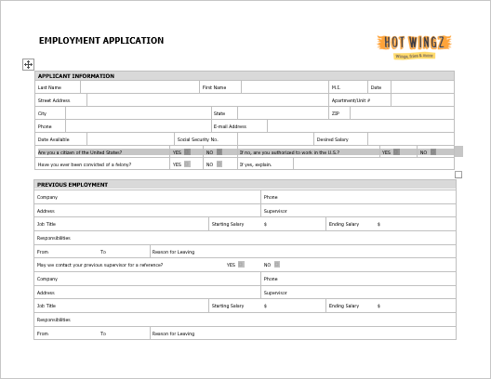

* Portrait means the page is oriented **vertically**.

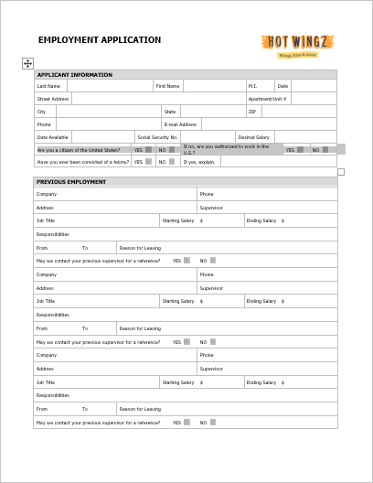

To change page orientation:

1. Select the **Layout** tab.
2. Click the **Orientation** command in the Page Setup group.

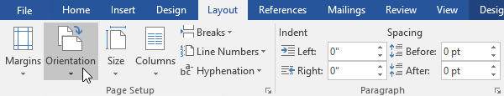

1. A drop-down menu will appear. Click either **Portrait** or **Landscape** to change the page orientation.

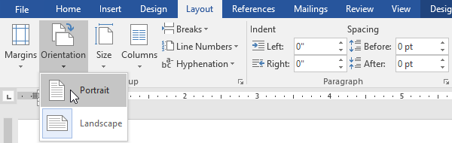

1. The page orientation of the document will be changed.

Page size

By default, the **page size** of a new document is 8.5 inches by 11 inches. Depending on your project, you may need to adjust your document's page size. It's important to note that before modifying the default page size, you should check to see which page sizes your printer can accommodate.

To change the page size:

Word has a variety of **predefined page sizes** to choose from.

1. Select the **Layout** tab, then click the **Size** command.

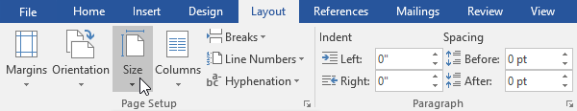

1. A drop-down menu will appear. The current page size is highlighted. Click the desired **predefined** **page size**.

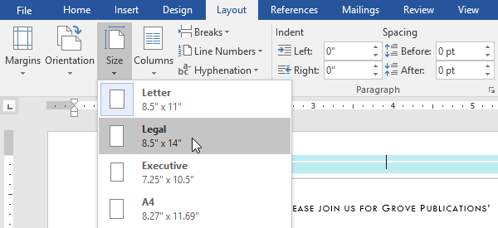

1. The page size of the document will be changed.

To use a custom page size:

Word also allows you to customize the page size in the **Page Setup** dialog box.

1. From the **Layout** tab, click **Size**. Select **More Paper Sizes** from the drop-down menu.

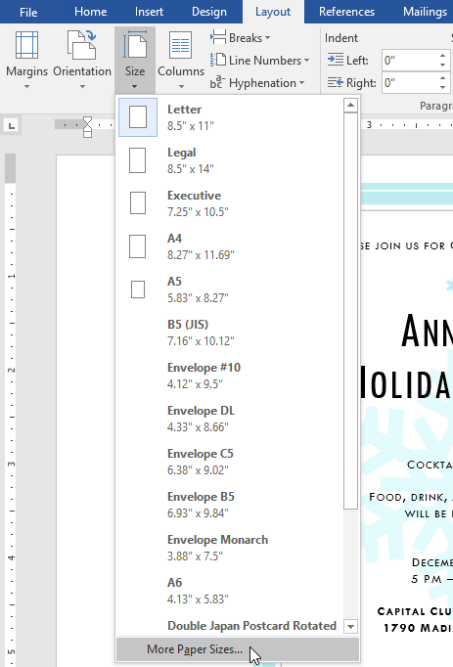

1. The**Page Setup** dialog box will appear.
2. Adjust the values for**Width** and **Height**, then click **OK**.

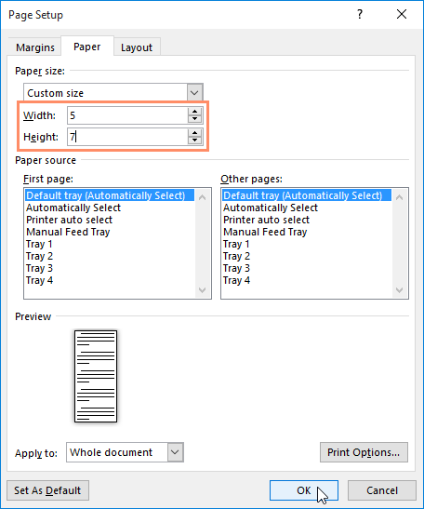

1. The page size of the document will be changed.

Page margins

A **margin** is the **space** between the text and the edge of your document. By default, a new document's margins are set to **Normal**, which means it has a one-inch space between the text and each edge. Depending on your needs, Word allows you to change your document's margin size.

To format page margins:

Word has a variety of **predefined margin sizes** to choose from.

1. Select the **Layout** tab, then click the **Margins** command.

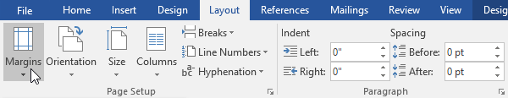

1. A drop-down menu will appear. Click the **predefined margin size** you want.

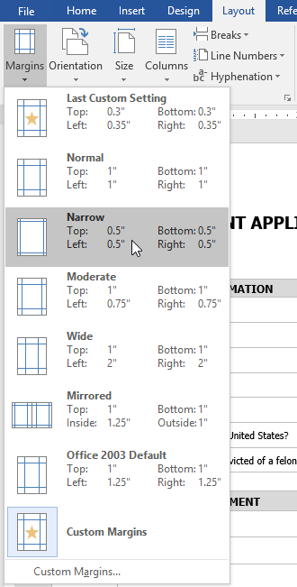

1. The margins of the document will be changed.

To use custom margins:

Word also allows you to customize the size of your margins in the **Page Setup** dialog box.

1. From the **Layout** tab, click **Margins**. Select **Custom Margins**from the drop-down menu.

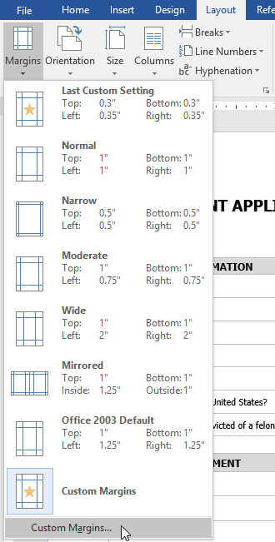

1. The **Page Setup** dialog box will appear.
2. Adjust the values for each margin, then click **OK**.

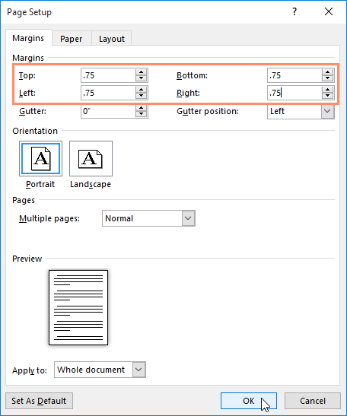

1. The margins of the document will be changed.

You can also open the Page Setup dialog box by navigating to the Layout tab and clicking the small **arrow** in the bottom-right corner of the **Page Setup** group.

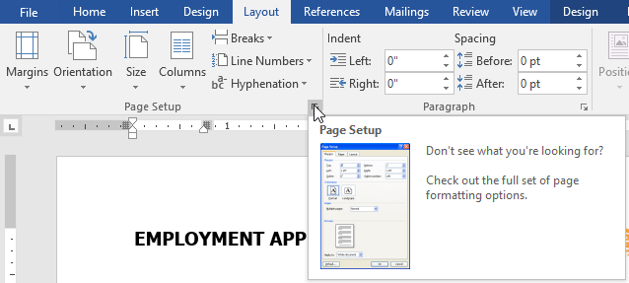

You can use Word's convenient **Set as Default** feature to **save** all of the **formatting** changes you've made and automatically apply them to new documents. To learn how to do this, read our lesson on [**Changing Your Default Settings in Word**](http://www.gcflearnfree.org/word-tips/changing-your-default-settings-in-word/1/).

Challenge!

1. Open our [**practice document**](https://media.gcflearnfree.org/content/5c09497777c0500354728565_12_06_2018/word_pagelayout_practice.docx).
2. Change the **page orientation** to **Portrait**.
3. Change the **page size** to **Legal**. If Legal size is not available, you can choose another size such as **A5**.
4. Change the **margins** to the **Narrow** setting.
5. When you're finished, your document should be one page if using Legal size. It should look something like this:

