Show your web search skills by finding the answers to the following questions and placing them with a screenshot of the web page where you found the answer and upload the document to Class Dojo.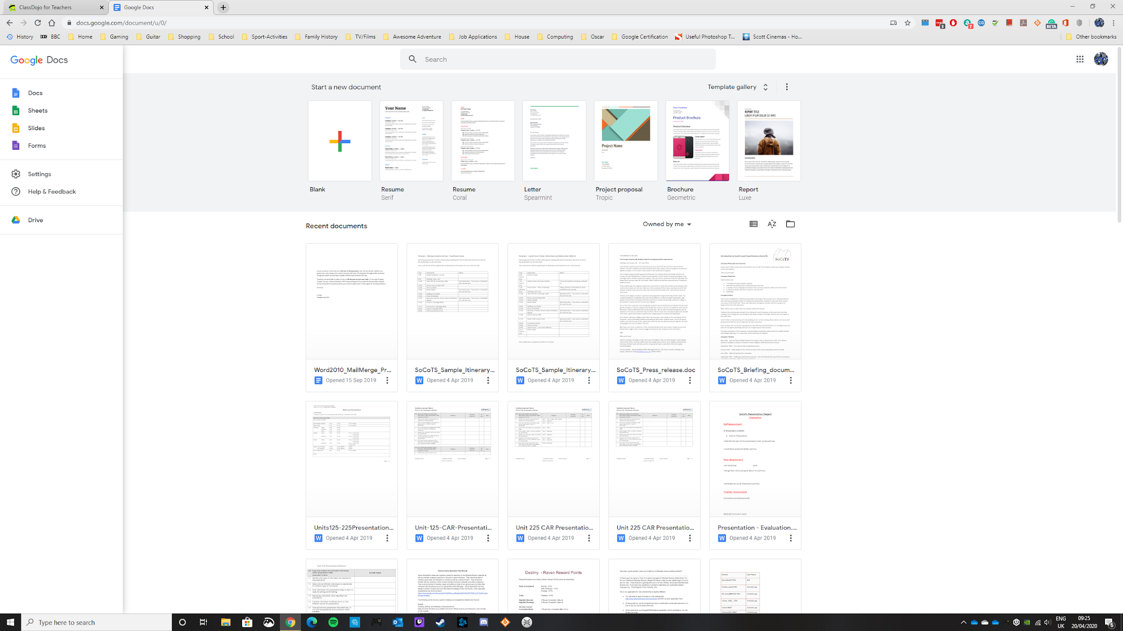

You can use Office 365 (use your school email & password to log in) or Google Docs (You will need to log in with your personal Gmail if you have one) to complete this task.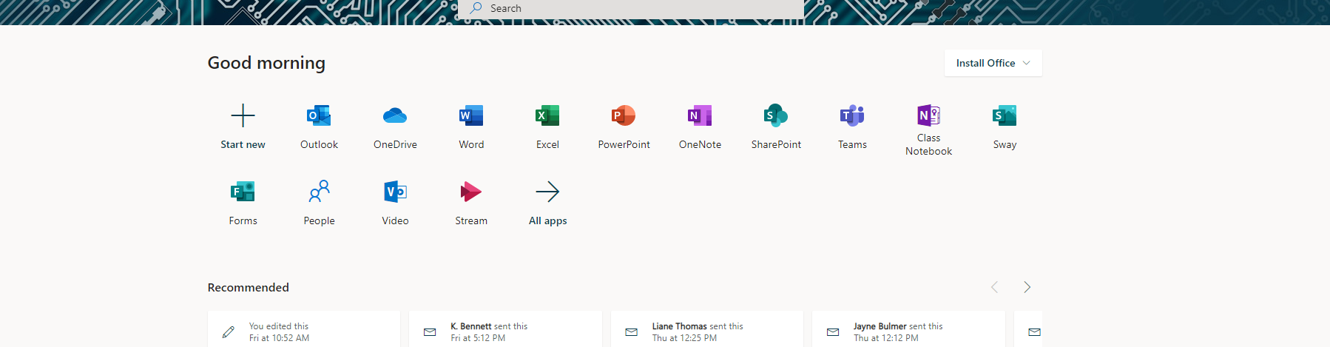

**Questions**

1. From which language is the word ‘ketchup’ derived?
2. Which is the country with the biggest population in Europe?
3. Who portrayed Edward Scissorhands?
4. What are made and repaired by a cobbler?
5. What is an endoscope used to examine?
6. Apart from producing films, what was the other passion of Howard Hughes?
7. What colour are the four stars on the flag of New Zealand?
8. How many states make up the United States of America?
9. Which English football team plays its home matches at Old Trafford?
10. Mr Carson is the name of the butler in which popular TV costume drama?