**Metric Unit Conversions**

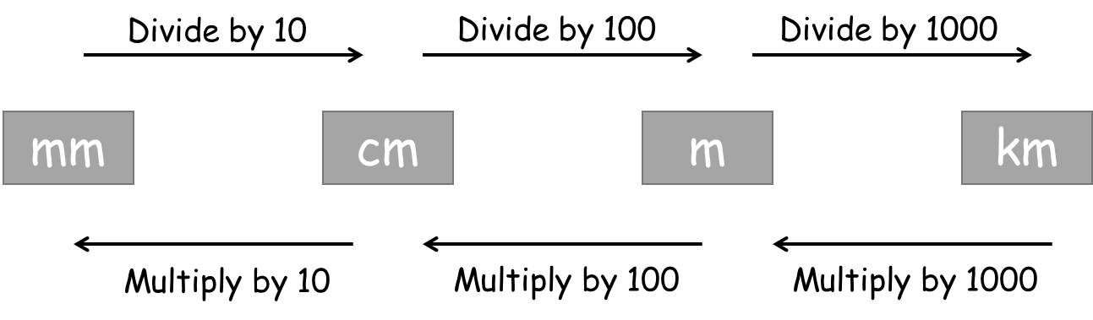**A: Convert these lengths**

1. 6 m = _____ cm
2. 210 mm = _____ cm
3. 5.3 km = _____ m
4. 0.84 m = _____ cm
5. 54 000 mm = _____ km
6. 0.067 km = _____ mm

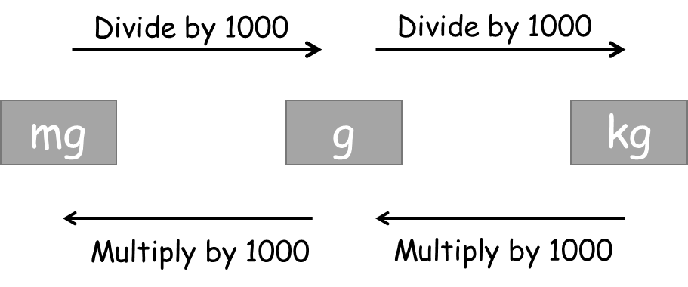**B: Convert these weights**

1. 3000 g = _____ kg
2. 5 kg = _____ g
3. 560 g = _____ kg
4. 35 000 mg = _____ kg
5. 9.48 kg = _____ g
6. 256 g = _____ kg

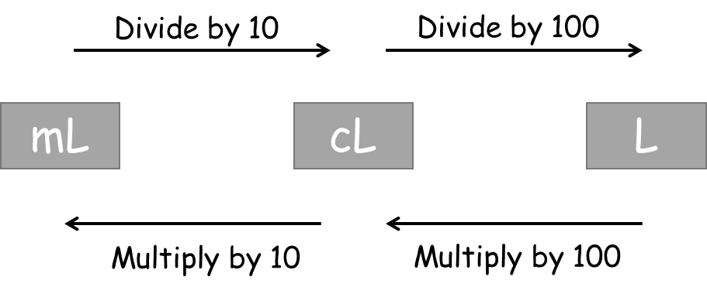**C: Convert these volumes**

1. 2000 mL = _____ L
2. 500 cL= _____ L
3. 45 000 mL = _____ L
4. 65 L = _____ ml
5. 525 ml = _____ cl
6. 465 400 ml = _____ L

**D: Exam Questions**

**Q1.**

Logan says, "140 millilitres is more than 1.2 litres". Is he right? You must explain your answer.

Hint: Convert 140 millilitres to litres to help you compare

..........................................................................................................................................

..........................................................................................................................................

..........................................................................................................................................

**(Total for Question is 2 marks)**

**\*Q2.**

Tony runs to keep fit. He wants to run a total of 20 km each week. Here are the distances Tony ran last week.

Hint: Convert all the measurements to km as decimals, then add together

6.25 km 4 km 750 m 8 ½ km

Did Tony run 20 km last week? You must show how you got your answer.

**(Total for Question is 3 marks)**

**Q3.**

Jack is 1.78 m tall. Amy is 5 cm taller than Jack. How tall is Amy?

Hint: What is 5 cm in metres?

**(Total for Question is 2 marks)**