**Yr 7 and 8 Art** Summer term, Week 1, LT.

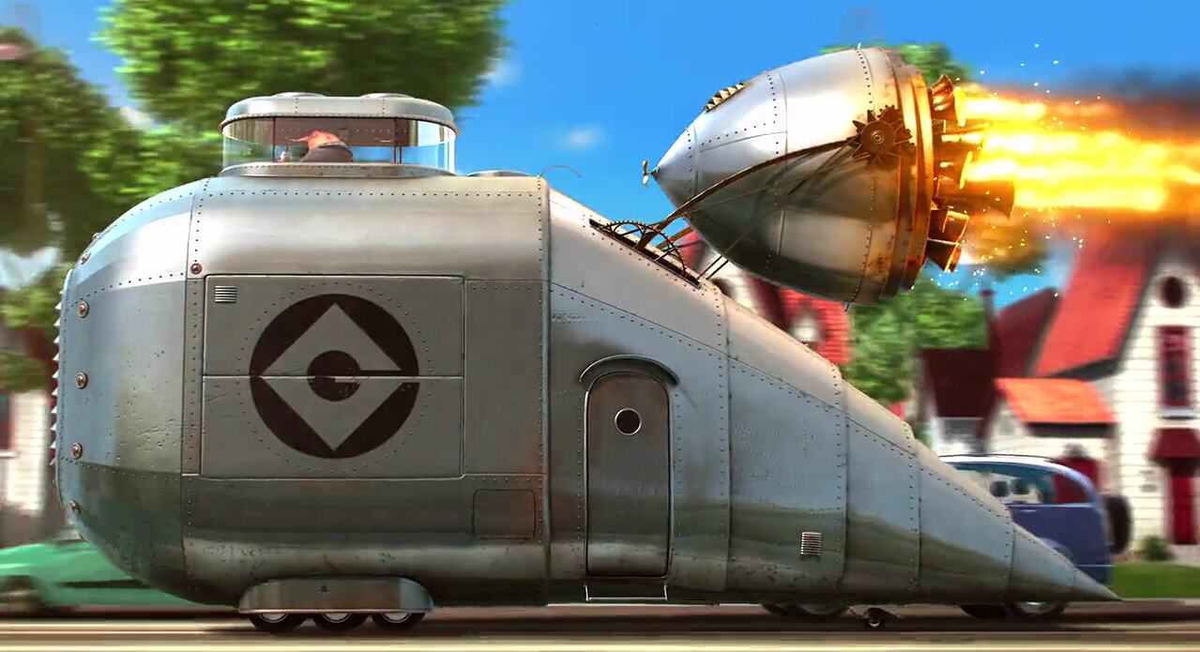

**Design**

Design is a massive area of art from fashion to architecture.

This week I’d like your ideas for an invention. You can **make, draw or write** about your invention. I’m hoping to see some pretty wacky ideas, the crazier the better.

This is all about **ideas** so don’t worry too much about your drawings.

**Task**

Design/invent a method of transport for a Superhero or Supervillain

**Consider:**

* **Your client (superhero/supervillain) what are they like, what do they need? What super powers do they have or how evil are they?**
* **How many places can your transport travel? e.g. air, water, desert etc.**
* **What gadgets will help?**
* **How is it powered?**

**Have a go and send me photos if you can, Liane**